Magnetostimulated Anisotropy of Conductivity
and Corbino-Like Current in Composite Conductors

V.R.Sobol¹, O. N. Mazurenko¹, and M. Zoli²

¹ National Academy of Sciences, Institute of Solid State and Semiconductor Physics
Brovka Street 17, 220072 Minsk, Belarus
Fax: + 375-172-840888; email: sobol@ifttp.bas-net.by

² Istituto Nazionale Fisica della Materia,
Dipartimento di Matematica e Fisica, Universita di Camerino
Via Madonna delle Carceri, 62032 Camerino, Italy
Fax: + 39-0737-632525; email: zoli@mail.publigraphic.it

Abstract

The problem of steady field distribution in double-strip conductor having the electric contact in interface is studied. The interface is orthogonal to magnetic field. The peculiarity is that components are hyrotropic due to an action of magnetic field. Some new approaches for this problem are discussed. The analysis is based on the phenomenological macroscopic equations for steady field including the hypothesis of existence of transverse current in every strip. The expression for effective resistivity is obtained as an intermediate case between two limit geometries of the single conductor on the one hand and disk conductor on the other hand.

1. Introduction

Pure aluminum is a popular material for stabilizing of large current superconductors on the reason that aluminum shows lower resistivity and lower magnetoresistance than copper. The combination of low resistive aluminum and mechanically strong and heat conductive copper may improve the recovery currents and total functioning of superconductor. However the enhancement of magnetoresistance due to Hall currents take place because the polarity of the Hall effect in aluminum is opposite to that in copper. Here the problem of resistivity enhancement in double strip composite conductor consisted of components having opposite polarities of Hall coefficients is discussed [1, 2]. Composite components have the electric contact in the interface being orthogonal to an external magnetic field. The own magnetic field is neglected.

2. Approach

Some new approaches for this problem are developed. That is the hypothesis of an existence of transverse current similar to Corbino current in disk shaped samples is applied for this problem [3]. For the simplicity of analysis the model type of conductor is used as a conductor consisted of components having similar type of conductivity and resistivity tensor including the fact that one of component is usual aluminum conductor with hole type of conductivity (Al⁺) but another component is a hypothetical quasi-aluminum conductor having electron type of conductivity (Al⁻). As a result the conductivity and resistivity tensors of these components are the same in modulo excluding of diagonal linear on magnetic field components being opposite in sign.

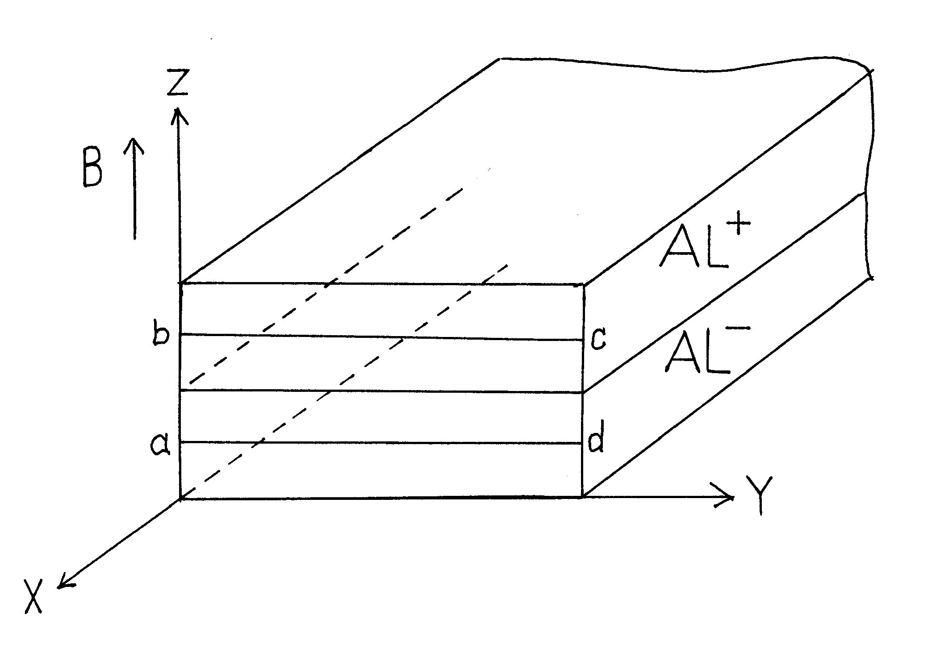
Fig. 1 Composite double strip conductor and its arrangement in an external magnetic field.

Double strip composite conductor model is displayed in Fig. 1. The conductor is uniform along transport X-direction and a primary electric field is applied along this direction. The magnetic field is oriented along Z-axis. The strips of conductor have the same dimensions. In steady state the equations that govern the transport process and transverse Hall mechanism generation are

$∇×E=0\text{ ; }j=σE\text{ ; }E=ρj$ (1)

Here E is electric field vector, j is current density vector, σ is conductivity tensor being equal to the reciprocal of resistivity tensor ρ. In this task

$\begin{aligned}ρ=\left(\begin{matrix}ρ_{\text{xx}} & ρ_{\text{xy}} & ρ_{\text{xz}} \\ ρ_{\text{yx}} & ρ_{\text{yy}} & ρ_{\text{yz}} \\ ρ_{\text{zx}} & ρ_{\text{zy}} & ρ_{\text{zz}}\end{matrix}\right)\text{ ; }ρ({\text{Al}}^{+})=ρ^{+}\text{; }ρ({\text{Al}}^{−})=ρ^{−}\text{ ; } \\ ρ_{\text{yx}}^{+}=−ρ_{\text{xy}}^{+}=\text{RB}\text{; }ρ_{\text{yx}}^{−}=−ρ_{\text{xy}}^{−}=−\text{RB}\end{aligned}$ (2)

All other components of ρ⁺ and ρ⁻⁻ are the same order of resistivity in zero magnetic field. The basic suggestion is that primary transport electric field component E_{x} is uniform through the double strip conductor. The total problem of this approach is to define the effective resistivity of composite conductor ρ_{ef} being the coefficient of proportionality between electric field E_{x} and averaged transport current density through strips <j_{x}>.

$ρ_{\text{eff}}=\frac{E_{x}}{j_{x}>}$ (3)

3. Calculation and Results

On the base of tensor relations between current density and electric field components it is clear that the conditions for an existence of transverse current of Hall nature take place. Really the electric Hall field due to gyrotropy of one component is shorten by conducting medium of another component. Respectively the electric Hall field of another component is shorten by the conducting medium of the first component. So for the any closed counter in the plane ZX (for instance abcd, Fig.1) the summarizing of Hall electromotive forces takes place and as a result the circular current along this counter exists. The circular current is similar to Corbino current along closed circular counter but the difference is that the current under discussion is generated in the counter being parallel to magnetic field but Corbino current is generated in the counter being orthogonal to magnetic field. Of course the transverse current is zero if the components of double strip conductor are the same in conductivity or under conditions of magnetic field absence. Using an integral form of equation for electric field circulation along closed counter of double strip conductor it is possible to get the expression for the magnetostimulated current. As a result the transverse component of this current is

$j_{y}=−\frac{ρ_{\text{yx}}}{ρ_{\text{yy}}+ρ_{\text{zy}}\frac{z}{b}}j_{x}$ (4)

Here b is a width of strips, z is any coordinate defining the distance from interface. In this expression the mechanism of involvement of carriers along z-direction under an action of external magnetic field is neglected because the level of a of current generation along z-direction is very small in comparison with the scope of transverse and transport current. Actually the Hall components of resistivity tensor in strong magnetic field are much higher of all other components and such an approximation is rather valid. Following equation (4) the values of current j_{y} and transport current j_{x} are the functions of geometric parameters b and z. When the ratio z/b is large the transverse current is small and for the counter having small ratio z/b the transverse current has definite non-small magnitude. For comparison Corbino current for aluminum conductor under neglecting of involvement of charge along z-direction is equal

$j_{y}=−\frac{ρ_{\text{yx}}}{ρ_{\text{yy}}}j_{x}$ (5)

This equation takes place for the thin disk samples placed in coaxial magnetic field which acts on radial carrier movements between current contacts on inner and outer diameters of disk. Taking into account tensor relations between electric field and current density vector the connection for transport current density j_{x} distribution with an electric field component along transport direction E_{x} can be obtained

$j_{x}=\frac{1}{ρ_{\text{xx}}}\frac{1}{1+\frac{σ_{\text{xy}}ρ_{\text{yx}}\frac{b}{z}}{σ_{\text{yy}}(ρ_{\text{yy}}\frac{b}{z}+ρ_{\text{zy}})}}E_{x}$ (6)

Applying the procedure of averaging of transport current through the thickness of strip the final expression for the effective resistivity is the next

$ρ_{\text{eff}}=\frac{ρ_{\text{xx}}}{1−{\left(\frac{\text{RB}}{ρ_{\text{xx}}}\right)}^{2}\frac{b}{t}\text{ln}\left\{{\left[1+{\left(\frac{ρ_{\text{xx}}}{\text{RB}}\right)}^{2}\right]}^{−1}\frac{t}{b}+1\right\}}$ (7)

Here the diagonal component of resistivity tensor ρ_{xx} may be not only constant as in former suggestions but this component is allowed to have more complicated behavior close to real that of polycrystalline aluminum when not very strong linear dependence on magnetic field takes place.
Fig. 2 Effective resistance as a function of ratio b/t at different B, T: 3(1); 5(2); 10(3); ρ_{xx} = 5⋅10⁻¹¹Ω⋅m

In accordance with the Eq.(7) the effective resistivity is a function of ratio b/t where t is the thickness of strips. So for one limit case when b/t → 0 the effective resistivity of composite conductor is equal to diagonal component of resistivity tensor ρ_{xx}. Physically it means that the main part of current flows far from the conductor interface so in accordance with the principle of the minimum of entropy generation the systems trends to such a state that ensures the minimal resistance at definite level of current flowing through cross section. The transport current density j_{x} and transverse current density j_{y} are zero near interface of conductor. Other limit case when b/t → ∞ means that the thickness of every strip is so small in comparison with width that the process of shortening of transverse electric Hall field of every component with each other is a single process that can ensure the potentiality of steady electric field. As a result the transverse Hall current is generated and the path of carriers along transport direction is occupated with transverse drift so that on the unit length on path along transport direction the charge carrier has time to drift in transverse direction and the transverse path is of ρ_{yx}/ρ_{xx} higher than the path in transport direction. As a result the collisions of charge carriers with crystal structure imperfections generate a respective resistivity being higher of that mentioned above. For this second limit case the effective resistivity trends to the resistivity of Corbino that. Essentially at more realistic conditions of t/b ratio magnitude some interval case of resistivity have to take place (Fig.2).

4. Conclusion

The accepted expression for effective resistivity is rather idealized one as it operates with model composite conductor. However the approaches developed for this task here seems to be rather reliable as these allow to construct a real physical picture under the presence of opposite types of magnetostimulated gyrotropy in composite conductor consisted of double strips. The father steps in the study of this problem should be done in the direction of understanding the averaging procedure along transverse direction, the analysis of non-symmetric task on geometry and on conductive properties of components. The last thesis is adequate to the situation of real double-strip composite conductor consisted of aluminum and copper components.

References

[1] H. Kaneko and N. Yanagi, Cryogenics, Vol. 32, p. 1114, 1992.
[2] M. P. Krefta, O. R. Christianson, and J. H. Parker, Jr, Cryogenics, Vol. 36, p. 291, 1996.
[3] V. R. Sobol, O. N. Mazurenko, and A. A. Drozd, Adv. Cryog. Eng., Vol. 42, p. 1063, 1996.

