On Mode Spectrum Degenerations,
Quasi-Degenerations and Mode Polarization Transformations in Optical Chiral Waveguides

S.V. Demidov¹, K.V. Kushnarev¹, and V.V. Shevchenko²

¹ Radiophysics Department, Russian People Friendship University,
Mikluho-Maklay str. 6, Moscow, 117198, Russia.

² Institute of Radioengineering and Electronics,
Mokhovaya str. 11, Moscow, 103907, Russia.
E-mail: sto@mail.cplire.ru

Abstract

It is known [1-3], that mode spectrum degenerations take place for modes in chiral optical waveguides. Dispersion characteristics (curves) cross one another in the degeneration points, where propagation constants of two modes have the same values on some frequency. However, the more accurate analysis shows, that degeneration points are not exact but approximate only. In reality they are quasi-degeneration points. The dispersion curves do not cross one another, they close up near quasi-degeneration points. In this place, circular polarization of the modes converts: the right-handed polarization changes into left handed and on the contrary.

1. Theory

This paper deals with polarization transformations of modes in isotropic and anisotropic planar chiral optical waveguides and optical fibers. The general theory of spectral degenerations and quasi-degenerations and mode transformations is given in [4].
Let’s have the dispersion equation for even modes in a symmetrical chiral planar waveguide [2,3]

$\left(b−C_{+}\text{tan}C_{+}V\right)\left(b−C_{−}\text{tan}C_{−}V\right)−Δ^{2}C_{+}C_{−}t\text{tan}C_{+}V\text{tan}C_{−}V=0$, (1)
where
$b={\left(\frac{γ−{\text{kn}}_{o}}{{\text{kn}}_{o}Δ}\right)}^{\frac{1}{2}}$, (2a)
$V={\text{kn}}_{g}R{\left(2Δ\right)}^{\frac{1}{2}}$, (2b)
$k=\frac{ω}{c}$, (2c)
$Δ=\frac{n_{g}−n_{o}}{n_{g}}\text{<<}1$, (2d)
$C_{±}={\left(1∓2κV−b^{2}\right)}^{\frac{1}{2}}$, $κ=\frac{ρ}{2R{\left(2Δ^{3}\right)}^{\frac{1}{2}}}$, (2e)

$γ$ is a propagational constant, $ω$ is a circular frequency, $c$is a velocity of light; $n_{g}$ and $n_{o}$are refraction coefficients of the inside and outside media, $ρ$ is a chirality, $R$is a half-thickness of the guiding layer. In [3] we used approximation $Δ≈0$, and the dispersion curves were solutions of equations

$b−C_{+}\text{tan}C_{+}V=0$, (3a)

$b−C_{−}\text{tan}C_{−}V=0$. (3b)

For the solution $b=b_{q}$, $V=V_{q}$, where $b_{q}$ and $V_{q}$satisfy both equations (3) simultaneously, we had a degeneration point. Now the dispersion equation (1) can be presented approximately near this point as

$\left[\left(b−b_{q}\right)A_{+}−\left(V−V_{q}\right)B_{+}\right] \left[\left(b−b_{q}\right)A_{−}−\left(V−V_{q}\right)B_{−}\right]−Δ^{2}b_{q}^{2}C_{q+}^{2}C_{q−}^{2}=0$ (4)

where
$A_{±}=\left(1∓2{κV}_{q}\right)\left(1+b_{q}V_{q}\right)$,
$B_{±}=\left(1∓2{κV}_{q}\right)\left(C_{q±}^{2}∓{κV}_{q}\right)∓{κb}_{q}$, (5)
$C_{q±}={\left(1∓2{κV}_{q}−b_{q}^{2}\right)}^{\frac{1}{2}}$.

Due to (4) that point $b_{q},V_{q}$ is quasi-degeneration point [4].

$κ=0\text{.}1,Δ=0\text{.}\text{01}$

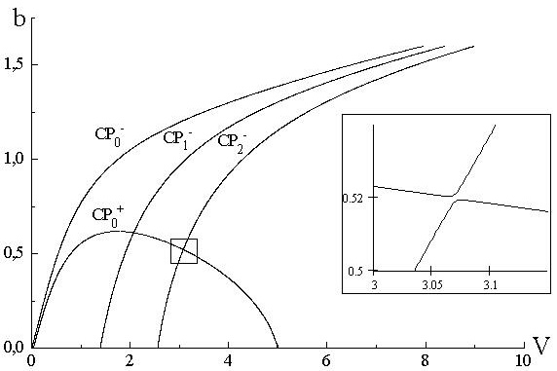

Fig. 1

It is possible to reconstruct the fine structure of dispersion curves that defines them near the points of quasi-degeneration from those results.

2. Discussion

It is interesting to consider the polarization evolution of both modes related to these curves. According to Fig. 1 while frequency increases and mode curves are passing the quasi-degeneration point of $b_{q}$,$V_{q}$ the mode ${\text{CP}}_{0}^{+}$with right-handed polarization converts into ${\text{CP}}_{2}^{−}$ with left handed polarization. And how can a circular polarized mode change the direction of field rotation? It seems at first sight that it is necessary for this kind of transformation that the speed of rotation has to slow down to zero and only after this the polarization handiness changes. But this process is impossible. The frequency of rotation of a field vector and wave length of a circular polarized mode cannot change essentially on a respectively small frequency interval near the quasidegeneration point. That is why only the following process of polarization conversion can take place. Both polarizations are approximately circular they are slightly elliptical. The ellipticity grows while the dispersion curve approaches the quasi-degeneration point. In the nearest area the polarization appears to be linear and parallel to the boundary for the upper curve with a smaller phase velocity and perpendicular for the lower curve with greater phase velocity. Having passed those area the polarization becomes elliptical but with an opposite direction of field vector rotation and then approximately circular again. This takes place for optical chiral waveguides with a little difference of refraction coefficients of a guiding and external media.
Although all mentioned above dealt with even modes of a planar chiral waveguide the same relates to odd modes. But the dispersion curves’ intersection points for even and odd modes are strictly degenerational because the dispersion equations for even and odd modes are exactly independent.

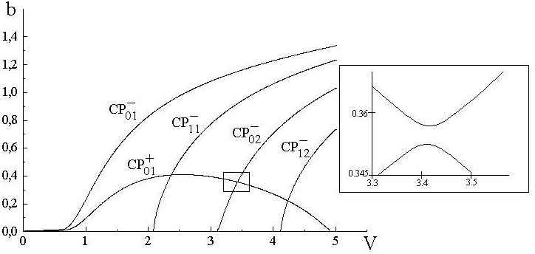

Fig. 2

We have the similar results for modes in chiral optical fiber with the same angular variations of fields (Fig. 2),
$κ=0\text{.}1, Δ=0\text{.}\text{01}$

and for modes in anisotropic planar chiral waveguide (Fig. 3), where modes always have elliptical polarization [5]. In Fig. 3 $σ=e/4Δ$, $ε_{x}=ε_{g}\left(1+e\right)$, $ε_{y}=ε_{z}=ε_{g}=n_{g}^{2}$, where $x,y$ are transverse and $z$ is longitudinal coordinates, $x$ is parallel to the boundaries of the waveguide and in (2)

$C_{±}={\left[1+σ∓{\left(κ^{2}V^{2}+σ^{2}\right)}^{\frac{1}{2}}−b^{2}\right]}^{\frac{1}{2}}$, $κ=\frac{ρ_{x}+ρ_{y}}{4R{\left(2Δ^{3}\right)}^{\frac{1}{2}}}$. (6)

$κ=0\text{.}1, σ=0\text{.}5, Δ=0\text{.}\text{01}$

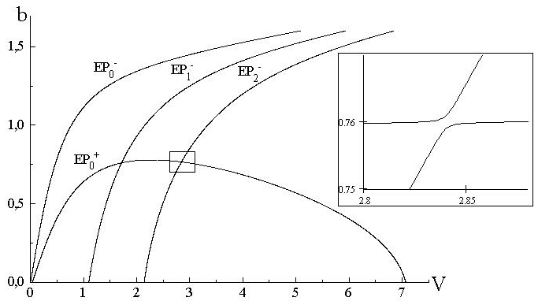

Fig. 3

References

[1] I. V. Lindell, A. H. Sihvola, S. A. Tretyakov, and A. J. Viitanen, Electromagnetic Waves in Chiral and Bi-isotropic Media. Boston-London: Artech House, 1994.
[2] S. V. Demidov, K. V. Kushnarev, and V. V. Shevchenko, “On mode dispersion properties of chiral optical planar waveguides”, Journal of Radioelectronics, No. 4, 1999, http://jre.cplire.ru/jre/apr99/1/text.html.
[3] S. V. Demidov, K. V. Kushnarev, and V. V. Shevchenko, “Dispersion properties of the modes of chiral planar optical waveguides”, J. of Communications Technology and Electronics, vol. 44, No. 7, pp. 827-832, 1999.
[4] V. V. Shevchenko, “On spectral degenerations, quasi-degenerations and wave transformations in dielectric waveguides and lightguides”, J. of Communications Technology and Electronics, vol. 45, 2000 (in press).
[5] V. V. Shevchenko, “Waves in chiral-anisotropic medium”, J. of Communications Technology and Electronics, vol. 44, No. 11, pp. 1198-1201, 1999.

