A Spectral Behavior of Fractal Aggregates
in the Quasi-static Approximation

V. N. Pustovit and G. A. Niklasson

Department of Solid State Physics, University of Uppsala
The Angstrom laboratory, SE-75121 Uppsala, Sweden
Fax: +46 18 500131; email: Pustovit.Vitaly@angstrom.uu.se

Abstract

In this paper we present a method to calculate optical properties of small fractal clusters of spheres constructed in a recursive manner in the quasistatic approximation. To calculate optical properties of octahedral generator of six spheres we used the dipole-dipole approximation developed in Shalaev theory. After S iterations we received a fractal cluster of N particles with determined optical properties.

1. Introduction

Electromagnetic phenomena in random metal-insulator composites, such as rough thin films, cermets, colloidal aggregates and other, have been intensively studied for the last two decades [1]. These media typically include small nanometer – scale particles or roughness features. Often nanocomposites, within a certain interval of length-scale, are characterized by a random fractal, i.e. scale – invariant structure. Fractals look similar at different scales; in other words, a part of the object resembles the whole [2]. In this paper we study optical absorption by deterministic, recursively constructed three – dimensional fractal aggregates consisting of spherical metallic particles. Usually, it is quite difficult to calculate optical properties of fractal clusters containing a large number of particles. The most convenient way is to use the scale – invariant properties of the fractal structure. To illustrate the geometrical construction of the fractal, consider a cluster of $N=6$ spheres as shown in Fig.1. Here we depict how the first two stages of such a construction can be built from individual spherical particles. First we calculate the optical properties of a small cluster – generator of six spheres. Further we shall use these aggregates as generators for an iterative procedure to obtain the fractal system after a number of recursive iterations. The optical parameters of these generated clusters are assigned to a new “effective particle”, which instead will participate in the iteration process. Finally, after S iterations, we receive a fractal cluster of N particles with determined optical parameters. For generators containing six spheres we have applied a method of taking into account pair dipole-dipole interactions between particles within the cluster, developed in the works of Shalaev [3-4].

- Polarizability of a Cluster and Recursive Approach

We assume that the fractal cluster is located in a continuous dielectric matrix with permittivity $ε_{0}=1$. We also assume that the size of generator and of the all cluster after S iterations is small compared with the wavelength of incident radiation. This fact will allow us to neglect retardation effects and describe whole system in quasi-static limit. Following the results of previous works [3-4], we can write induced dipole moments of the generator in the form:
$d_{i,α}=α_{0}\left(E_{α}^{\left(0\right)}+\sum_{i≠j}{W_{\text{ij},\text{αβ}}d_{j,β}}\right)$ (1)
$W_{\text{ij},\text{αβ}}=⟨iα\left|W\right|jβ⟩=\left[δ_{\text{αβ}}−3\frac{{\left(r_{\text{ij}}\right)}_{α}{\left(r_{\text{ij}}\right)}_{β}}{r_{\text{ij}}^{2}}\right]\frac{1}{r_{\text{ij}}^{3}}$ (2)

where $W_{\text{ij},\text{αβ}}$ is a quasi-static interaction operator between each pair of particles; $α,β=x,y,z$ are the coordinates of particles in three dimensional space; $r_{\text{ij}}=\left|r_{i}−r_{j}\right|$ is a distance between particles; $r_{i}$ and $r_{j}$ are the origins of spheres $i$ and $j$, respectively.

$α_{0}={\text{Ba}}^{3}=\frac{ε−ε_{0}}{ε+2ε_{0}}a^{3}$ (3)

is the usual dipole polarizability of the spherical particle with radius a . The polarizability tensor of the i-th particle interacting with all neighboring $j≠i$ particles can be found from Eq. (1-2) [3-4]:

$α_{i,\text{αβ}}\left(ω\right)=\sum_{j,n}{\frac{\left\langle iα | n\right\rangle \left\langle n | jβ\right\rangle }{α_{0^{−1}}\left(ω\right)+w_{n}}}$ (4)

where $w_{n}$ and $\left\langle iα | n\right\rangle \left\langle n | jβ\right\rangle$ are eigenvalues and eigenvectors of the interaction matrix $W$respectively, i.e. $W|n⟩=w_{n}|n⟩$. The average polarizability of the generator is given by:

$α\left(ω\right)=13N\sum_{i}{\text{Tr}\left[α_{\text{αβ}}^{\left(i\right)}\right]}$ (5)
where N is a number of particles in generator.
Consider now the octahedral cluster with N = 6 spheres shown in Fig. 1 with sphere radius a and distance between nearest neighbors $R=2aσ$. According to the iteration scheme [5], the radius of the equivalent sphere after the first step of iteration (S = 1) is $a\left(1\right)=R/2+a=a\left(1+σ\right)$. The same procedure can be applied, for example, to the octahedral generator with N = 7 spheres, where after the first iteration the equivalent radius becomes $a\left(1\right)=a\left(1+\sqrt{2}σ\right)$. Taking into account self-similar properties of fractal cluster, we can assume that after S iterations the radius of the single “effective sphere” in the final cluster is [6]
$a\left(s\right)=a{\left(1+σ\right)}^{s}$ (6)

for the N = 6 generator. After S steps of the iteration process for N = 6 generator, the recursive relation for $B^{\left(s\right)}$, which should be used for calculation of “effective sphere” polarization, has a form:

$B^{\left(s\right)}={\left(1+σ\right)}^{−3}\sum_{n}{\frac{\left\langle iα | n\right\rangle \left\langle n | jβ\right\rangle }{{\left(B^{\left(s−1\right)}\right)}^{−1}+w_{n}a^{3}{\left(1+σ\right)}^{3\left(s−1\right)}}}$ (7)

Therefore, the extinction cross-section of the fractal cluster with generator N = 6 after S iterations should be:
$σ_{e}^{\left(s\right)}=4π{\text{kN}}^{s}\text{Im}\left[a^{3}{\left(1+σ\right)}^{3\left(s−1\right)}\sum_{n}{\frac{\left\langle iα | n\right\rangle \left\langle n | jβ\right\rangle }{{\left(B^{\left(s−1\right)}\right)}^{−1}+w_{n}a^{3}{\left(1+σ\right)}^{3\left(s−1\right)}}}\right]$ (8)
where $k=2πλ$ and $λ$ denotes the wavelength of incident radiation in the system.

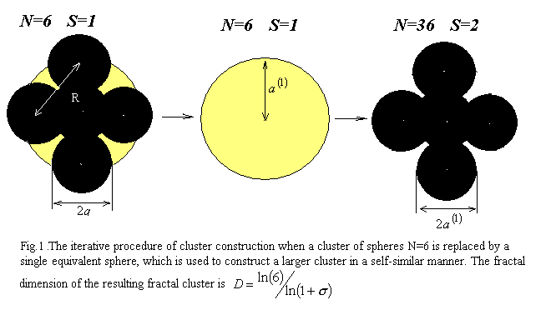

- Results and Discussion

We have applied this theory to the deterministic fractal of metallic particles N = 6 depicted in Fig. 1 for the S = 1, 2 iteration steps. In Fig. 2 we present the results of our calculations by plotting the extinction efficiency of the fractal cluster N = 6 as a function of $ω=ωω_{p}$, where $ω_{p}$ is a plasma frequency of metallic particles. We have specified the properties of the particle material by the values $ω_{p}=1\text{.}\text{37}⋅{\text{10}}^{\text{16}}s^{−1}$, $γ=7\text{.}\text{14}⋅{\text{10}}^{\text{13}}s^{−1}$. The average size of particles $a=\text{30}\overset{∘}{A}$ and diameter $d=\text{61}\overset{∘}{A}$, gives us the parameter $σ=1\text{.}\text{017}$. We observe that the main features of the spectra are present already in the dipolar approximation of the Shalaev theory [3-4]. Our results show that the response of the system is strongly dependent on the volume fraction of particles in cluster, which decreases rapidly with arising number S of iterations. This is very interesting, because in the normal non-fractal structures the volume fraction of particles should be approximately constant with increasing number of iterations (i.e. number of particles in the cluster $N→∞$). In the same time the magnitude of spectra also decreases with arising number S. Indeed, the self-similar properties of fractal clusters, which save its geometrical structure, after S iterations make them more “transparent”. We have also observed that, in particular, the low frequency peak shift to lower frequencies as parameter $σ$decreases. It should be noted that the two peaks in Fig.2. are in qualitative agreement with theoretical results obtained by application of Ausloos theory [7]. In experiments on random fractal metal aggregates, a two-peak absorption, qualitatively similar to Fig.2 has been observed [8-11]. We are not aware of any data on the behavior of these peaks as a function of aggregate size or particle separation. For linear chains, the low frequency peak shift to low frequency with increasing number of particles [12]. It would be interesting to investigate whether this is the case for anisotropic fractals also. Our method could, in principle, be used for two-scale anisotropic fractal structures. The present method has large similarities with Discrete Dipole Approximation [13] largely used by astrophysicists. This may point a way to extend the method to large particle clusters beyond the quasistatic limit.
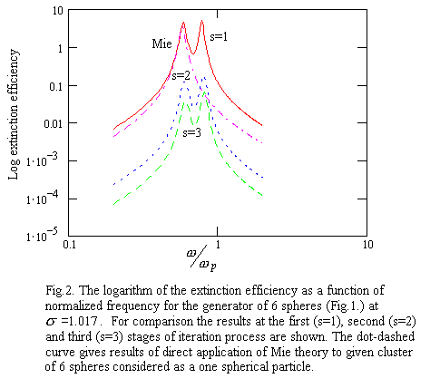

Acknowledgement

One of the authors (V.N.Pustovit) would like to thank the WENNER-GREN foundation for the given support to his work at Uppsala University, Sweden.

References

[1] Electron Transport and Optical Properties of Inhomogeneous Media, J. C. Garland and D. B. Tanner (Eds.), AIP, New York, 1987; Electron Transport and Optical Properties of Inhomogeneous Media (ETOPIM 3), W .L. Mochan and R. G. Barrera (Eds.), North-Holland, Amsterdam, 1994; Physica A, vol. 241, no. 1-2, pp. 1-452, 1997, Proceedings of ETOPIM 4, A. M. Dykhne, A. N. Lagerkov, and A. K. Sarychev (Eds).
[2] B. B. Mandelbrot, The Fractal Geometry of Nature. Freeman, San Francisco, 1982.
[3] V. M. Shalaev, Physics Reports, vol. 272, no. 2-3, 1996.
[4] V. M. Shalaev, Nonlinear Optics of Random Media. Springer Tracts in Modern Physics, vol. 158, 1999.
[5] F. Claro and R. Fuchs, Phys.Rev. B, vol. 44, no. 9, pp. 4109-4116, 1991.
[6] P. M. Hui and D. Stroud, Phys. Rev. B, vol. 33, no. 4, pp. 2163-2169, 1985.
[7] J. M. Gerardy and M. Ausloos, Phys.Rev. B, vol. 25, pp. 4204-4210, 1982.
[8] D. Schonauer, M. Quinten, and U. Kreibig, Z. Phys. D, vol. 12, pp. 527-532, 1989.
[9] U. Kreibig, M. Quinten, and D. Schonauer, Physica Scripta vol. 13, pp. 84-92, 1986.
[10] J. P. Wilcoxon, J. E. Martin, and D. W. Schaefer, Phys. Rev. A, vol. 39, pp. 2675-2688, 1985.
[11] H. Hasegawa, N. Satoh, K. Tsujii, and K. Kimura, Z. Phys. D, vol. 20, pp. 325-327, 1991.
[12] M. Quinten and U. Kreibig, Surface Science, vol. 172, pp. 557-577, 1986.
[13] K. Lumme and J. Rahola, Astrophys. J., vol. 425, pp. 653-667, 1994.

