Chiral Low Frequency Resonance
on an Anisotropically Conductive Cylinder
with a Thin Longitudinal Slot

P. A. Malyshkin and A. D. Shatrov

Institute of Radio Engineering and Electronics
Russian Academy of Sciences
Pl. Vvedenskogo 1, 141120 Fryazino, Moscow Region, Russia
Tel. (7-095)526 92 66; Fax (7-095) 203 84 14; E-mail palmal@mail.ru

Abstract

The problem is considered of the diffraction of a circularly polarized wave by an anisotropically conductive cylinder of small radius with a thin longitudinal slot. It is shown that, for a certain relation between the pitch angle of the helical conductive lines and the angular dimension of the slot, one can observe resonance phenomenon that manifests itself in a sharp increase in the scattering cross-section; for a right-handed helix, this resonance phenomenon occurs only when the incident wave is left circularly polarized. At the resonance frequency, the scattered field is left-circularly polarized and has a uniform directional pattern.

1. Introduction

It is known that certain cylindrical objects of small cross dimensions have resonance properties. These are, for instance, a metal cylinder with a longitudinal slot [1] and anisotropically conductive strip where the direction of conductivity makes a small angle with the edges of the strip [2]. The fields scattered by these objects are linearly polarized. In [3], a low frequency chiral resonance was observed in a hollow cylinder with the pitch angle of the helical conductive lines close to $π/2$. For right-handed helices, the resonance appears for right circularly polarized wave. The scattered field at the resonance is right circularly polarized and its angular directivity can be described by $\text{cos}ϕ$.

Fig. 1 Anisotropically conductive cylinder with a longitudinal slot.

2. Theory

In this work, we investigate a new electromagnetic object, which is a non-closed cylindrical surface with helical conductivity. We considered the diffraction of a circularly polarized plane wave propagating perpendicular to the $z$ axis by the surface $r=a,$ $\left|ϕ\right|<θ$ with the following anisotropic-conductivity boundary conditions:

$E_{z}^{+}=E_{z}^{−}$, (1a)

$E_{ϕ}^{+}=E_{ϕ}^{−}$, (1b)

$E_{z}\text{sin}α+E_{ϕ}\text{cos}α=0$, (1c)

$\left(H_{z}^{+}−H_{z}^{−}\right)\text{sin}α+\left(H_{ϕ}^{+}−H_{ϕ}^{−}\right)\text{cos}α=0$, (1d)

where $α$ is the pitch angle of the helix. The $z$-components of the incident electromagnetic field is given by the formulas

$H_{z}^{0}=\text{exp}\left[−\text{ikr}\text{cos}\left(ϕ−ϕ_{0}\right)\right],$ (2a)

$E_{z}^{0}=±i\text{exp}\left[−\text{ikr}\text{cos}\left(ϕ−ϕ_{0}\right)\right]$. (2b)

Here and below, the upper and lower indices correspond to the right and left hand circular polarized waves.
The problem is reduced to an integral-differential equation for the surface current $f\left(ϕ\right)$, which is related to the jump in the tangential component of the magnetic field by the formulas

$H_{z}^{+}−H_{z}^{−}=−f\left(ϕ\right)\text{cos}α$, (3a)

$H_{ϕ}^{+}−H_{ϕ}^{−}=f\left(ϕ\right)\text{sin}α$. (3b)

The equation for $f\left(ϕ\right)$ is as follows:

$\frac{d^{2}}{{dϕ}^{2}}\int_{−θ}^{θ}{A\left(ϕ−ϕ^{'}\right)f\left(ϕ^{'}\right)dϕ^{'}+\frac{d}{dϕ}\int_{−θ}^{θ}{B\left(ϕ−ϕ^{'}\right)f\left(ϕ^{'}\right)d}}ϕ^{'}+\int_{−θ}^{θ}{C\left(ϕ−ϕ^{'}\right)f\left(ϕ^{'}\right)dϕ^{'}}=F\left(ϕ\right)$ (4)

The kernels $A$, $B$, and $C$ are determined by the Green function for open space,

$G\left(r,ϕ,r^{'},ϕ^{'}\right)=\frac{i}{4}H_{0}^{\left(2\right)}\left\{ k{\left[r^{2}+r^{}−2rr^{'}\text{cos}\left(ϕ−ϕ^{'}\right)\right]}^{12} \right\}$, (5)

as follows:

$A=\frac{{\text{cos}}^{2}α}{\text{ka}}G\left(a,ϕ,a,ϕ^{'}\right)\text{cos}\left(ϕ−ϕ^{'}\right)$, (6a)

$B=\frac{{\text{cos}}^{2}α}{\text{ka}}\left[G\left(a,ϕ,a,ϕ^{'}\right)+a\frac{∂}{∂r}G\left(a,ϕ,a,ϕ^{'}\right)\right]\text{sin}\left(ϕ−ϕ^{'}\right)$, (6b)

$C=\text{ka}{\text{sin}}^{2}αG\left(a,ϕ,a,ϕ^{'}\right)+\text{ka}{\text{cos}}^{2}αG\left(a,ϕ,a,ϕ^{'}\right)\text{cos}\left(ϕ−ϕ^{'}\right)$. (6c)

The left-hand side of equation (4) is determined by the expression

$F\left(ϕ\right)=\left[i\text{cos}α\text{cos}\left(ϕ−ϕ_{0}\right)∓\text{sin}α\right]\text{exp}\left[−\text{ika}\text{cos}\left(ϕ−ϕ_{0}\right)\right]$. (7)

The current $f\left(ϕ\right)$ obeys the conditions

$f\left(θ\right)=f\left(−θ\right)=0$. (8)

For the asymptotic case

$\text{ka}\text{<<}1$, $μ=\text{tg}α\text{<<}1$, $π−θ\text{<<}1$, (9)

an analytical solution is derived in the following form:

$f\left(ϕ\right)={\text{Df}}_{0}\left(ϕ\right)$ , (10)

where

$f_{0}\left(ϕ\right)=\text{ln}\left[\text{cos}\frac{ϕ}{2}+{\left({\text{cos}}^{2}\frac{ϕ}{2}−{\text{cos}}^{2}\frac{θ}{2}\right)}^{12}\right]−\text{lncos}\frac{θ}{2}$, (11)

$D=\frac{2\text{ka}\left(\text{ka}∓2μ\right)}{1+{\left(\text{ka}\right)}^{2}\left\{2−i\frac{π}{2}\left[{\left(\text{ka}\right)}^{2}+4μ^{2}\right]\right\}\text{lncos}\frac{θ}{2}}$. (12)

3. Scattering Cross-Section

The total scattering cross-section $σ$ calculated from the current (10) is determined by the formula

$kσ=\frac{π^{2}}{8}{\left(\text{ka}\right)}^{2}\left[{\left(\text{ka}\right)}^{2}+4μ^{2}\right] {\left|D\right|}^{2}{\text{ln}}^{2}\text{cos}\frac{θ}{2}$. (13)

As it follows from (12), just as in the case of the problem for a metal cylinder with a longitudinal slot, the resonant frequency is determined by the formula

$\text{ka}=\left|2\text{lncos}\frac{θ}{2}\right| ^{−12}$. (14)

Note that, at the frequency

$\text{ka}=2μ$, (15)

a right circularly polarized wave does not interact with the cylinder. Therefore, a cylinder with the geometrical parameters $μ$ and $θ$ related by the formula

$μ^{2}=1/8\left|\text{lncos}\frac{θ}{2}\right|$ (16)

exhibits ideal chiral properties at the resonant frequency (14). It does not interact with a right circularly polarized wave and strongly scatters a left circularly polarized wave. Figure 2 shows the scattering cross-sections versus frequency for the left and right circularly polarized waves for $θ={\text{175}}^{∘}$ and $α={\text{12}}^{∘}$.

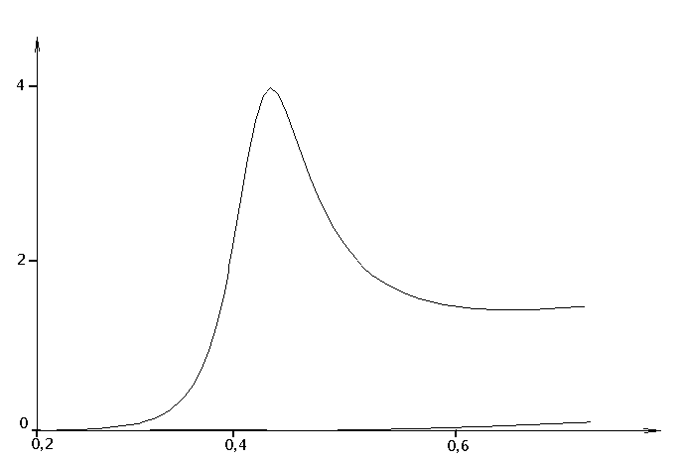$k σ$$\text{ka}$

Fig. 2 Scattering cross-sections for left (resonance curve) and right circularly polarized waves for $θ={\text{175}}^{∘}$, $α={\text{12}}^{∘}$.

Thus, an anisotropically conductive cylinder with a longitudinal slot manifests strong polarization selectivity with respect to left and right circularly polarized waves. This fact makes it possible to use such cylinders for the design of artificial chiral media and structures [4].

Acknowledgement

This work was supported by the Russian Foundation for Basic Research, project no. 98-02-16197.

References

[1] A. I. Nosich and V. P. Shestopalov, “An electromagnetic analogue of the Helmholtz resonator,” Dokl. Akad. Nauk SSSR, vol. 234, no. 1, pp. 53−56, 1977.
[2] P. A. Malyshkin and A. D. Shatrov, “Resonance scattering of electromagnetic waves by a Narrow anisotropically conductive strip,” Radiotekh. Elektron., vol. 44, no. 7, pp. 800−805, 1999.
[3] A. N. Sivov, A. D. Chuprin, and A. D. Shatrov, “Low-frequency resonance in a hollow circular cylinder with perfect conductivity along helical lines,” Radiotekh. Elektron., vol. 39, no. 10, pp. 1534−1538, 1994.
[4] B. Z. Katsenelenbaum, E. N. Korshunova, A. N. Sivov, and A. D. Shatrov, “Chiral electromagnetic objects,” Usp. Fiz. Nauk, vol. 167, no. 11, pp. 1201−1212, 1997.

