Resonant Response of Chiro-Ferrite Media
under FMR and Chiro-FMR Conditions

G. Kraftmakher, Y. Kazantsev, and A. Kozyrkov

Institute of Radioengineering and Electronics
Russian Academy of Sciences
11, Mokhovaya str., 103907, Moscow, Russia
Fax: (095)2038414; E-mail: vsolosin@ms.ire.rssi.ru

Abstract

We present here the experimental results about some features of the microwave resonant `effects which can be excited in chiro-ferrite media under a constant magnetic field. These results are obtained from the measurement of the transmission, reflection and absorption coefficients in rectangular waveguides, using cylindrical samples of many isolated oriented multistart helices with ferrite core inside. Here we show that in the case of the FMR excitation the resonant effects are displayed as two coupled resonances (the main chiral resonance and the FMR), which interfere with each other. If the conditions of the Chiro-FMR excitation are fulfilled, the chiral resonance is controlled in a limited frequency band. For a certain value of the constant magnetic field the Chiro-FMR experiences bifurcation with large frequency separation, which can be more than one order larger than the chiral resonance width. The reflection anti-resonance and absorption decrease are observed under bifurcation. The resonant response to governing magnetic field depends essentially on the ferrite concentration.

1. Introduction

As it was shown in [1], the chiro-ferrite composite media, which combine the properties of chiral and ferrite components, are considerably more complicated than originally envisioned.
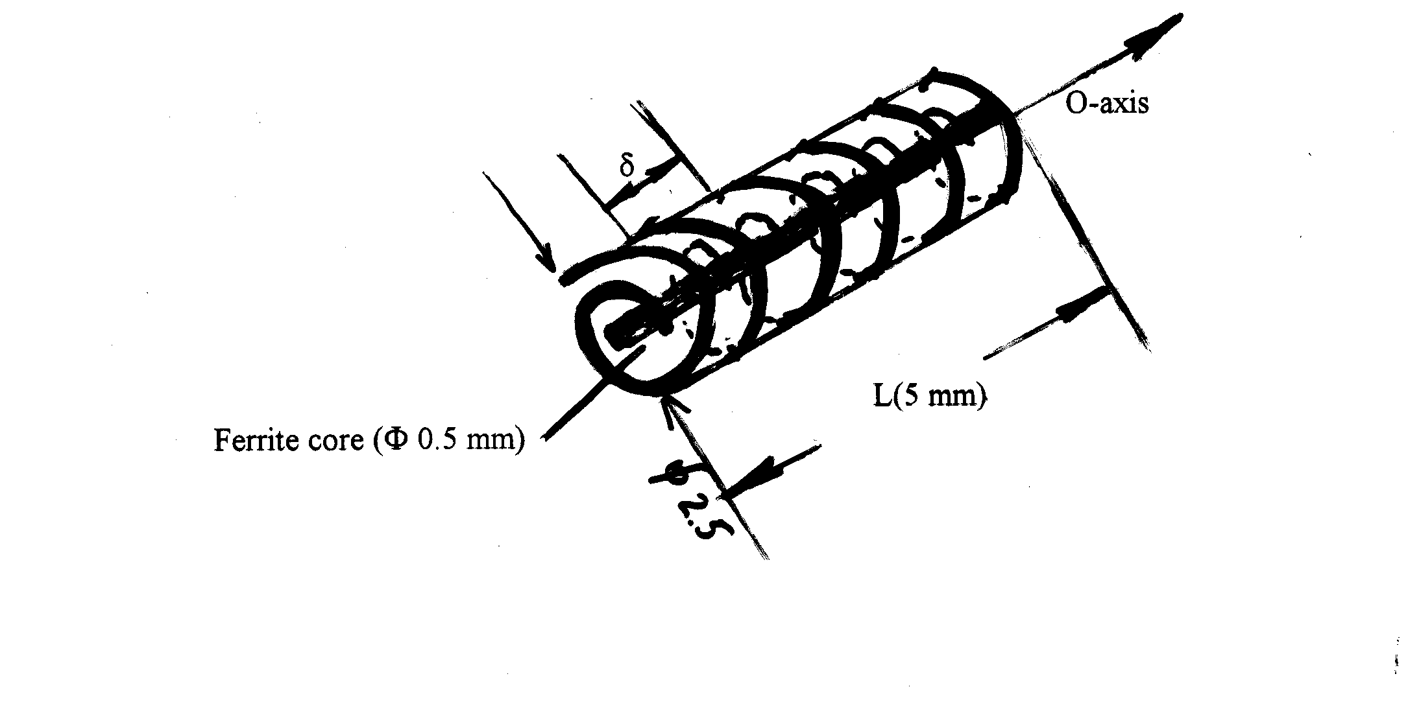Indeed, the resonant effects are specific. Even the well-known ferromagnetic resonance (FMR), resonant interaction of the microwave magnetic field with a magnetized ferrite, is unusual because of the influence of the chiral resonance (ChR). Chiro-FMR is the resonant interaction of the magnetic moment of a chiral inclusion (induced by the microwave fields) with a magnetized ferrite. Chiro-FMR is unique as it excited only in chiro-ferrite media. In our previous works [2,3] we investigated the excitation conditions and the possibility to separately observe FMR and Chiro-FMR, using cylindrical samples with oriented multistart helical structures with ferrite core inside. Here we use similar samples. The samples (Figure 1) were made, rolling a piece of material with parallel copper (tungsten) threads to helical tube around the O-axis. Each of the threads forms the isolated helix, and one-dimensional chiral medium of many oriented multistart helices (much less than wavelength) with common O-axis is created. When we add ferrite core inside helical tube, the chiro-ferrite is formed.
Fig. 1

2. Chiro-FMR

The Chiro-FMR features are investigated in rectangular waveguides for two cases of chiral resonance excitation. The first case is H-excitation, when the microwave magnetic field h is parallel to the O-axis, and the resonant losses are displayed as magnetic losses. The second case is E-excitation, when the microwave electric field E is parallel to the O-axis of helices, and the resonant losses are displayed as dielectric losses. To observe the Chiro-FMR it is necessary to apply the constant magnetic field H_{o} perpendicular to the O-axis
Figure 2 shows evolution of frequency dependencies of Transmission (a) and Reflection (b) with variations of the constant magnetic field in the case of H-excitation. We see that main chiral resonance moves away from the primary resonant frequency to high frequencies, and its intensity (the resonance level) decreases. Under a certain value of the constant magnetic field (H_{B} = 3200 Oe) the Chiro-FMR experiences bifurcation, and two identical weak resonances can be observed: previous first resonance at high frequency and a new, second resonance. The second resonance appears at low frequency about a primary resonance and moves to the primary frequency with increasing intensity, while the first resonance continues to weak and becomes invisible at all. It is observed coexistence of two resonances in a limited area of a constant magnetic field about the bifurcation field: H_{coex} = H_{B} ± 200 Oe. Under bifurcation we see a deep minimum of the Reflection resonance instead of traditional maximum (anti-resonance in presence of absorption).
In Figures 3 and 4, dependencies of resonance intensity (Fig. 3a), resonance frequency (Fig. 3b), and resonant absorption (Fig. 4) on the constant magnetic field H₀ are demonstrated in the form of two branches connected with both the first resonance (before bifurcation) and the second resonance (under bifurcation and after it). In Figure 3b, frequency dependence of the FMR for single ferrite core (without the chiral sample, but in Chiro-FMR geometry, H₀ ⊥ to the core axis and H₀ ⊥ to the h-field) is presented also. Analyzing frequency dependencies of the Chiro-FMR and the FMR (Fig. 3b), one can note the correlation between bifurcation field (H_{B} = 3200 Oe) and the FMR field of single ferrite at the frequency equal to the primary chiral resonance, f = 10,4 GHz at H_{o} = 0.

3. FMR

The FMR features are investigated in the case of E-excitation, when one can observe separately the FMR under H₀ ⊥ to the h-field (|| to the O-axis). In Figure 5 we illustrate the frequency dependence of Transmission at different values of the constant magnetic field H₀. When H₀ = 0, only chiral resonance (ChR) is observed. Applying a constant magnetic field, the FMR is excited and moves to high frequencies. Till frequencies of the FMR and the ChR are far from each other, influence of ChR on FMR is very weak. When the FMR is near the ChR, two coupled resonances and interaction between them are observed, as Figure 6 confirms. When the FMR approaches the ChR, its intensity decreases while ChR intensifies. Next, increasing the constant magnetic field, we observe intensification of the FMR and decrease of the ChR intensity (Fig. 6a). Frequency shift of ChR caused by the FMR influence is weak, as Figure 6(b) shows.

4. Conclusion

The Chiro-FMR Features

1. Controlled ChR in limited frequency band. Strong frequency shift.
2. Bifurcation effect, coexistence of two resonances. Decrease of resonant absorption.
3. Correlation between bifurcation and FMR fields.
4. Influence of ferrite concentration on frequency band.
The FMR Features

1. Two resonances: main ChR and moving FMR.
2. Interaction between FMR and ChR near the main resonance frequency.
3. Weak frequency shift of ChR.

Acknowledgement

The work is supported by the Russian Fund of Basic Research, Grant Ν 99-02-39009.

References

[1] W. S. Weiglhofer, A. Lakhtakia, and B. Michel. “On chiroplasmas and chiroferrites,” Proc. of Bi anisotropics'98, Braunschweig, Germany, pp. 9 – 12.
[2] Y. N. Kazantsev and G. A. Kraftmakher, “Chiral medium-ferrite and electric dipole-ferrite structures: Chiral-ferromagnetic, dipole-ferromagnetic and ferromagnetic resonances,” Proc. of Chiral'95, Pennsylvania, USA, pp. 161-170.
[3] G. A. Kraftmakher and Y. N. Kazantsev, “Experimental investigation of response of chiral media and chiral media-ferrite structures to microwave radiation and governing magnetic field,” Advances in Complex Electromagnetic Materials, Dordrecht Kluwer Academic Publishers, 1997, pp. 341-358.

c)

Fig. 2 Chiro-FMR - Evolution of frequency dependences with variations of the constant magnetic field H₀ (H-excitation): (a) Transmission; (b) Reflection; (c) Bifurcation of transmission resonance and reflection anti-resonance by H₀ = 3200 Oe.

a)
a)
b)

b)

Fig. 3 Chiro-FMR: (a) Resonance intensity of transmission (reflection) I_{T} (I_{R}); (b) Resonance frequencies.

Fig. 4 Chiro-FMR: Magnetic resonant losses N_{m} and dielectric resonant losses N_{d}.
a)
Fig. 5 Moving FMR and main chiral resonance (ChR) with variations of the constant magnetic field H₀.
b)

Fig. 6 FMR-conditions, FMR and ChR: (a) Resonance intensities of transmission; (b) Resonance frequencies.

a)
b)

Fig. 7 Influence of ferrite concentration F₁ and F₂ on ChR under FMR and Chiro-FMR: (a) ChR intensities of transmission under FMR and Chiro-FMR; (b) ChR frequencies under FMR and Chiro-FMR.

