Analytical and Numerical Study
of Reflection of Plane Waves from Two-dimensional Bianisotropic Array Substrated by a Dielectric Shield

M. S. Kondratjev¹ , P. A. Belov¹, and C.R. Simovski¹

¹ Physics Department, St. Petersburg Institute of Fine Mechanics and Optics,
Sablinskaya 14, 197101 St. Petersburg, Russia
Phone/fax: 7-812-3456198 ; email: kondrat@green.ifmo.ru

Abstract

This work is devoted to the problem of the electromagnetic wave reflection from regular two-dimensional infinite array of bianisotropic particles situated near the surface of a dielectric shield (a metal-backed dielectric layer). We have to study the individual particle response separately in terms of the particle polarizabilities using antenna model. Then we study the analytical model of electromagnetic interaction between particles and between particles and dielectric shield. Finally we express dipole moments of arbitrary particle via an incident plane electromagnetic wave using self-consistency model and it leads us to reflection coefficient of structure. The numerical calculations are made for the structure with omega-particles.

1. Introduction

The problem of the plane electromagnetic wave reflection from various arrays (grids) of scatterers substrated by dielectric half-space or multilayer dielectric or dielectric-metal structures has been studied in the abundant literature. These works have a common feature: the problem can be strictly solved numerically within the frame of the so-called cell formulation. This formulation is based on the periodicity of the grid and yields to the boundary integral equations (BIE) for a unit cell. However, if one deals with the grids of bianisotropic particles or particles with three-dimensional geometry this problem hardly be explicitly solved using boundary conditions for the scatterer surface together with the boundary conditions for the shield. This way is very complicated for numerical solving therefore we propose to consider particles as dipoles and to study analytically the electromagnetic interaction in the grid in the presence of shield to evaluate their dipole moments and then to evaluate reflection coefficient of structure.

2. Theory

To solve the problem consider the particles as a couple of electric p and magnetic m dipoles with four known polarizabilities, expressing p and m via local fields E and H (If the particles are small compared to the wavelength but have a complex shape their response can be described by a couple of an electric dipole and magnetic dipole):
$\left\{\begin{matrix}p={\overline{\overline{a}}}_{\text{ee}}E+{\overline{\overline{a}}}_{\text{em}}H \\ m={\overline{\overline{a}}}_{\text{me}}E+{\overline{\overline{a}}}_{\text{mm}}H\end{matrix}\right.$ (1)
In the theory of the arrays in free-space, that we developed in [3,4], the local fields can be splitted in two parts: the incident wave fields $E_{0},H_{0}$ and the fields $E_{g},H_{g}$ produced by all other particles:
$\begin{aligned}\left\{E=E_{0}+E_{g} | \right.\end{aligned}$ (2)
for $E_{g},H_{g}$ we obtain:
$\left\{\begin{matrix}E_{g}=\sum_{\text{m,n}=−∞}^{+∞}{E_{p}^{\text{m,n}}+}\sum_{\text{m,n}=−∞}^{+∞}{E_{m}^{\text{m,n}}} \\ H_{g}=\sum_{\text{m,n}=−∞}^{+∞}{H_{p}^{\text{m,n}}+}\sum_{\text{m,n}=−∞}^{+∞}{H_{m}^{\text{m,n}}}\end{matrix}\right.$ (3)
there upper index is the position of particle in array (we exclude zero-particle, so $m^{2}+n^{2}≠0$), and lower index is the type of dipole produced field.
In the case of the normal incidence the dipole moments of different particles are simply equal to each other. In the case of oblique incidence we have a phase shift between fields acting on particles. It allows to express $E_{g},H_{g}$ via p, m:
$\left\{\begin{matrix}E_{g}={\overline{\overline{A}}}_{\text{ee}}p+{\overline{\overline{A}}}_{\text{em}}m \\ H_{g}={\overline{\overline{A}}}_{\text{me}}p+{\overline{\overline{A}}}_{\text{mm}}m\end{matrix}\right.$ (4)
there $A_{\text{αβ}}$ are double sums of fields of dipoles. And then, solving an algebraic set, to evaluate p, m through $E_{0},H_{0}$:
$\left\{\begin{matrix}p={\overline{\overline{F}}}_{\text{ee}}E_{0}+{\overline{\overline{F}}}_{\text{em}}H_{0} \\ m={\overline{\overline{F}}}_{\text{me}}E_{0}+{\overline{\overline{F}}}_{\text{mm}}H_{0}\end{matrix}\right.$ (5)

Then we can easily obtain reflection coefficient of structure [4]:
$\begin{aligned}\bar{\bar{R}}=Z_{e}\bar{\bar{T}}{\bar{\bar{F}}}_{\text{ee}}+Z_{e}η\bar{\bar{T}}{\bar{\bar{F}}}_{\text{em}}\bar{\bar{S}}+Z_{\text{em}}^{\text{me}}\bar{\bar{S}}{\bar{\bar{F}}}_{\text{me}}+Z_{\text{em}}^{\text{me}}η\bar{\bar{S}}{\bar{\bar{F}}}_{\text{me}}\bar{\bar{S}} \\ \bar{\bar{T}}=\bar{\bar{I}}+Z_{e}\bar{\bar{T}}{\bar{\bar{F}}}_{\text{ee}}+Z_{e}η\bar{\bar{T}}{\bar{\bar{F}}}_{\text{em}}\bar{\bar{S}}{\text{-Z}}_{\text{em}}^{\text{me}}\bar{\bar{S}}{\bar{\bar{F}}}_{\text{me}}−Z_{\text{em}}^{\text{me}}η\bar{\bar{S}}{\bar{\bar{F}}}_{\text{me}}\bar{\bar{S}}\end{aligned}$ (6)
where $Z_{e}{\text{,Z}}_{m},Z_{\text{em}}^{\text{me}},\bar{\bar{T}},\bar{\bar{S}}$are known constants and dyadics [4].
For the structures that we consider in present work (array substrated by dielectric shield) we apply the same procedure to solve the problem.
Split the fields E, H in (1) on three parts: the incident wave fields $E_{0},H_{0}$, the fields $E_{g},H_{g}$ produced by all the grid particles except the reference one and the fields $E_{s},H_{s}$ produced by the shield:
$\begin{aligned}\left\{E=E_{0}+E_{g}+E_{\text{sh}} | \right.\end{aligned}$ (2')

Here $E_{\text{sh}},H_{\text{sh}}$ are results of the shield polarization by the incident wave and by particles of the grid, so:
$\begin{aligned}\left\{E_{\text{sh}}=E_{1}+E_{2} | \right.\end{aligned}$ (7)
Here the first terms are fields of the first part of the shield polarization, induced by incident wave:

$\begin{aligned}\left\{E_{1}={\bar{\bar{R}}}_{s}E_{0} | \right.\end{aligned}$ (8)

where $R_{S}$ is the known reflection coefficient of the shield (see [2]). $E_{2},H_{2}$ are fields produced by second part of the shield polarization (induced by all the particles of the grid). We can split $E_{2},H_{2}$ into two parts:
$\begin{aligned}\left\{E_{2}=E_{\text{g'}}+E_{s} | \right.\end{aligned}$ (9)

there $E_{\text{g'}},H_{\text{g'}}$ are the fields of the shield polarization induced by all the particles of the grid except zero-particle and $E_{s},H_{s}$ are the fields of the shield polarization induced by zero-particle.
Substituting (7)-(9) into (2') we obtain:

$\begin{aligned}\left\{E=E_{0}+(E_{g}+E_{\text{g'}})+R_{s}E_{0}+E_{s} | \right.\end{aligned}$ (2'')

For $(E_{g}+E_{\text{g'}}),(H_{g}+H_{\text{g'}})$ we can write the following expression:

$\left\{\begin{matrix}E_{g}+E_{\text{g'}}=\sum_{\text{m,n}=−∞}^{+∞}{{\tilde{E}}_{p}^{\text{m,n}}+}\sum_{\text{m,n}=−∞}^{+∞}{{\tilde{E}}_{m}^{\text{m,n}}} \\ H_{g}+H_{\text{g'}}=\sum_{\text{m,n}=−∞}^{+∞}{{\tilde{H}}_{p}^{\text{m,n}}+}\sum_{\text{m,n}=−∞}^{+∞}{{\tilde{H}}_{m}^{\text{m,n}}}\end{matrix}\right.$ (3')

there ${\tilde{E}}_{\text{p,m}},{\tilde{H}}_{\text{p,m}}$ are the fields of dipoles in presence of dielectric shield. Analytical expressions for ${\tilde{E}}_{\text{p,m}},{\tilde{H}}_{\text{p,m}}$ we can obtain from [1]. In this work we find out the analytical expression for $E_{s}{\text{,H}}_{s}$ (so called self-action field) through p, m:

$$E_{s}(z)=−\frac{{\text{ωμ}}_{0}}{4{πk}_{0}}e^{{\text{2ik}}_{0}z}[\frac{{\text{ik}}_{0}}{\text{2z}}−\frac{1}{{\text{4z}}^{2}}−\frac{i}{{\text{8k}}_{0}z^{3}}−ε\left(\frac{{\text{ik}}_{0}}{z}−\frac{1}{{\text{2z}}^{2}}\right)+ε^{2}\left(\frac{{\text{ik}}_{0}(2ε+1)}{z(ε+1)}−\frac{1}{{\text{2z}}^{2}}−\frac{i}{{\text{4k}}_{0}z^{3}}\right)] p$$

So, finally substituting (2'') with (3') and (9) into (1) we express induced dipole moments of the particle via incident wave (5). The wave reflected from the structure is considered as a sum of re-radiation of the electric and magnetic dipoles of the array particles and re-radiation of the shield. Though the shield is excited by all the spatial harmonics produced by the grid the shield contribution into the reflected wave is results from the wave transmitting through the grid. Therefore we obtain for the reflection coefficient:

$R_{Ω}=R+{\text{TR}}_{S}e^{\text{2jkh}}$ (10)

where R and T are grid reflection and transmission coefficients, h is the grid altitude.

3. Numerical Calculations

The numerical calculation based on the formulae given above have been carried out for grid of omega-particles over metal-backed dielectric layer with following parameters (see Fig.1): grid periods a=b=15 mm, h=1..15 mm, l=1 mm, $ε=5$+2j (relative permittivity). Geometrical parameters of particles: R=2 mm (radius of loop), l=2 mm (length of the stem), r=0.05 mm (wire radius). The individual polarizabilities of particles calculated with use of antenna model and results [5]. On Figure 2 we present the absolute value of reflection coefficient of structure for h=1 (mark as 1), 5 (2), 10 (3) mm for frequency band f=5..15 GHz. Notice that the self-action model describe the resonance frequency shift (well-known experimental effect). Also we see that the reflectance from the shield (with weak attenuation) is reduced by the grid to 20-25% of initial value.
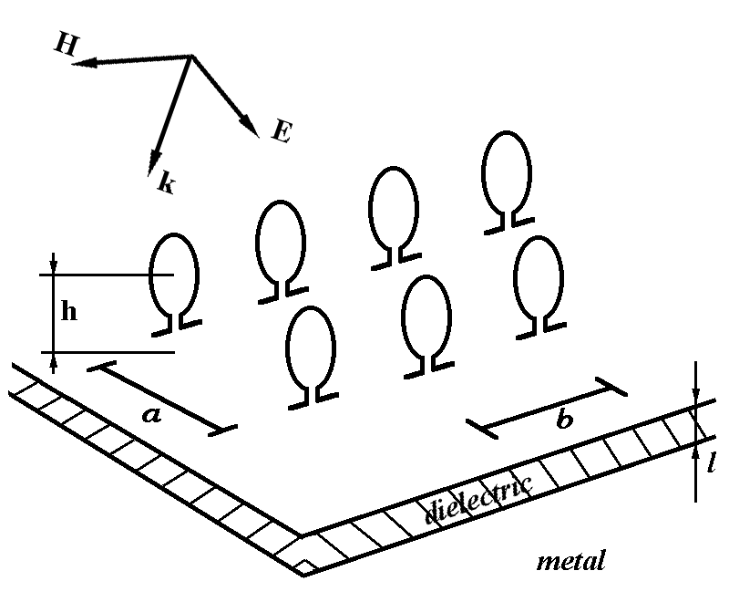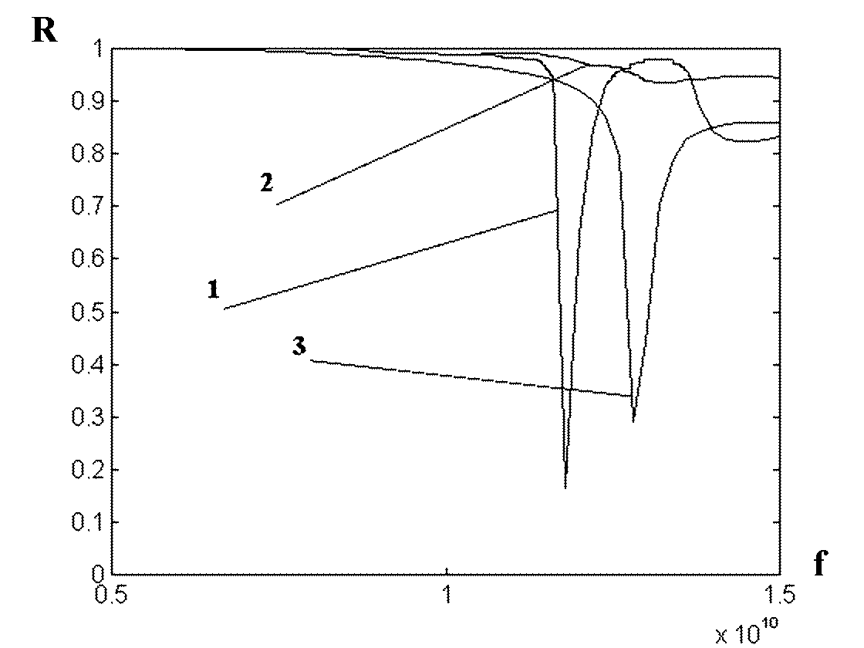
Fig. 1 Grid of omega-particles over dielectric shield. Fig. 2 Reflection coefficient depending on frequency.

4. Conclusion

We obtain analytical describing of reflection coefficients and induced dipole moment of structures consisting of regular two-dimensional infinite array of bianisotropic particles situated near the surface of a dielectric shield (a metal-backed dielectric layer). The theory taking into account electromagnetic interaction between scatterers and dielectric.

References

[1] R. W. P. King, “The electromagnetic field of a horizontal electric dipole in the presence of a three-layered region”, J. Appl. Phys., vol. 69, no. 12, pp. 7987-7995, 1991.
[2] C. R. Simovski, M. S. Kondratjev, and S. He, “Array of C-shaped wire elements for the reduction of reflection from a conducting plane”, Microwave and Optics Tech. Letters, vol. 22, no. 6, 2000.
[3] C. R. Simovski, M. S. Kondratjev, P. A. Belov, and S. A. Tretyakov, “Interaction effects in two-dimensional bianisotropic arrays”, IEEE Transactions on Antennas and Propagation, vol. 47, no. 9, pp. 1429-1439, 1999.
[4] M. S. Kondratjev, C. R. Simovski, and P. A. Belov, “Reflection and transmission of plane waves in bianisotropic planar grids”, in Proc. of SPIE 5th Symp. on Smart Structures and Materials, San Diego, USA, pp. 669-678, 1998.
[5] S. A. Tretyakov, C. R. Simovski, F. Mariotte, and T. G. Kharina, "Scattering by a single omega-shaped conductive particle and omega composite modeling", in Proc. of URSI Intern. Symp., St. Petersburg, Russia, pp. 639-635, 1995.

