Anisotropy of Electrical Properties of Mono-Layers
of Spherical Particles Located on Substrate

L.G. Grechko${}^{1}$, V.V. Gozhenko${}^{1}$, V.N. Malnev${}^{2}$, and K.W. Whites${}^{3}$

¹ Institute of Surface Chemistry National Academy of Sciences of Ukraine
Prospekt Nauki 31, 03022 Kyiv, Ukraine
email: user@surfchem.freenet.kiev.ua

² Taras Shevchenko Kyiv National University
Prospect Glushkov 6, 03142 Kyiv, Ukraine
email: vmal@phys.univ.kiev.ua

³ Department of Electrical Engineering, University of Kentucky
453 Anderson Hall, Lexington, KY 40506-0046, USA
Fax: +1 - 859 - 257 - 3092; email: whites@engr.uky.edu

Abstract

In this paper, we study the effects of a semi-infinite matrix disperse system on the external electromagnetic radiation in the electrostatic approximation. With the help of our previous technique, we obtain general expressions for the multipole expansion coefficients of the electric potential for a sphere accounting for the interaction between ambient particles and the substrate. The polarizability tensor and resonant frequencies of a single sphere show anisotropy due to the influence of a substrate.

1. Introduction

Interest in matrix disperse systems (MDS) is stimulated, first of all, by the possibility of manufacturing materials with predicted optical properties. At the same time, the properties of MDS may strongly differ from those of the materials used for the formation of MDS [1]. In the theoretical studies, MDS are usually considered as infinite systems.
In this work, we take into consideration the effects of an MDS interface. Namely, the MDS is considered as a half space of dielectric matrix with a plane interface separating it from another half space of homogeneous dielectric. The matrix is filled with spherical inclusions of different diameters that are randomly located. The results [2] obtained for the system of spheres on a dielectric substrate can be obtained from our model as a particular case. Basically, this work is a generalization of [3,4].

2. Theory

We consider the semi-infinite MDS consisting of dielectric spheres with different diameters embedded in a homogeneous dielectric (ambient) as shown in Fig. 1. The remainder of the half space is filled with another homogeneous dielectric (substrate). The system is placed in the electric field proportional to $e^{iwt}$. Let $e_{a}\left(w\right),e_{s}\left(w\right)$ and $e_{i}\left(w\right)$ be the dielectric functions of the ambient, substrate and the i^{th} sphere, respectively, and $R_{i}$ be the radius of the i^{th} sphere.
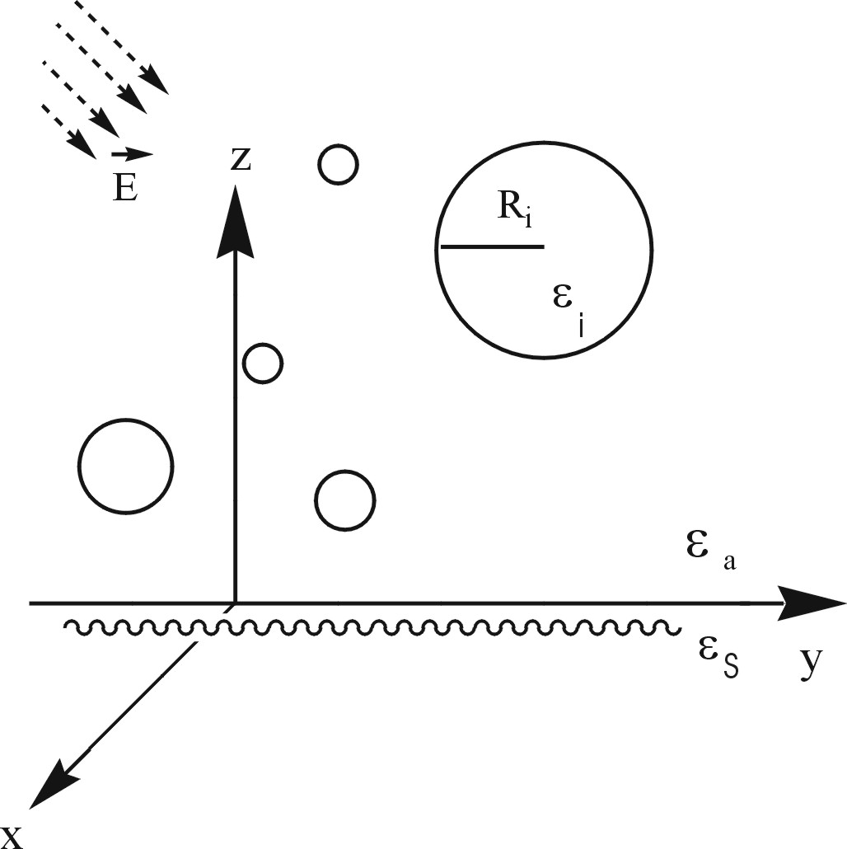
Figure 1 Geometry of the semi-infinite matrix disperse system.

Let the wavelength of the external electromagnetic field be much larger than radii of the spheres and the distances between them. In other words, we use the electrostatic approximation. In such a case, the potential of the electric field is a result of the interaction of the external field with the MDS and the substrate and satisfies the Laplace equation
$Dy\left(\vec{r}\right)=0$ (1)
in regions: I - inside MDS (outside of the spheres), II - inside the spheres, III - inside the substrate. We seek a solution of (1) in the following form:
${y^{I}=y_{\text{ext}}^{I}+\sum_{i}{y_{i−\text{th}\text{spere}}^{I}}+y_{\text{substrate}}^{I}\text{=- \{}\vec{E}}_{o}\vec{r}+\sum_{\text{ilm}}{A_{\text{lmi}}F_{\text{lmi}}}\left({\vec{ρ}}_{i}\right)+\sum_{\text{ilm}}{A_{\text{lmi}}^{'}F_{\text{lmi}}\left({\vec{ρ}}_{i}^{'}\right)}$ (2)
$y_{i}^{\text{II}}=\sum_{\text{lm}}{B_{\text{lm}}G_{\text{lm}}\left({\vec{ρ}}_{i}\right)}$; (3)
$y^{\text{IIII}}=y_{\text{ext}}^{\text{III}}+\sum_{\text{ilm}}{C_{\text{lmi}}G_{\text{lmi}}\left({\vec{ρ}}_{i}^{'}\right)}$; (4)
$\begin{aligned}ψ_{\text{ext}}^{I}=−{\vec{E}}_{0}\vec{r}=−\left(E_{\text{ox}}x+E_{\text{oy}}y+E_{\text{oz}}z\right) \\ ψ_{\text{ext}}^{\text{III}}=−{\vec{E}}_{0}^{'}\vec{r}=−\left({\text{aE}}_{\text{ox}}x+{\text{bE}}_{\text{oy}}y+{\text{cE}}_{\text{oz}}z\right)\end{aligned}$ (5)
where$F_{\text{lm}}\left(\vec{r}\right)≡r^{−l−1}Y_{\text{lm}}\left(\vec{r}\right)$; $G_{\text{lm}}\left(\vec{r}\right){ºr}^{l}Y_{\text{lm}}\left(\vec{r}\right)$; ${\vec{ρ}}_{i}º\vec{r}−{\vec{r}}_{i}$ ; ${\vec{ρ}}_{i}^{'}º\vec{r}−{\vec{r}}_{i}^{'}$; ${\vec{r}}_{i}$is a radius-vector of the center of the i^{th} sphere ; ${\vec{r}}_{i}^{'}$is a radius-vector of the image of the center of the i^{th} sphere.
The coefficients $A_{\text{lmi}},A_{\text{lmi}}^{'},B_{\text{lmi}},C_{\text{lmi}},a,b,c$are obtained after applying the boundary conditions for the continuity of the potential and its normal derivative on the limiting surfaces of regions I-II and I-III. This leads to the expressions
$a=\frac{e_{a}}{e_{s}}$; $b=c=1$,
$A_{\text{lmi}}^{'}={\left(−1\right)}^{l+m}A_{\text{lmi}}\frac{e_{a}−e_{s}}{e_{a}+e_{s}}$; $B_{\text{lmi}}=f\left(A_{\text{lmi}}\right)$; $C_{\text{lmi}}=A_{\text{lmi}}\frac{2e_{a}}{e_{a}+e_{s}}$, (6)
and to the equation defining $A_{\text{lmi}}$
$\begin{aligned}\sum_{l_{2}≠0}{}{\text{il}}_{2}m_{2}\end{aligned}$, (7)
where
$К_{l_{1}m_{1}j}^{l_{2}m_{2}i}α_{l_{1}j}H_{l_{1}m_{1}}^{l_{2}m_{2}}\left\{F_{\text{LM}}^{'}\left({\vec{r}}_{i}−{\vec{r}}_{j}\right)+{\left(−1\right)}^{l_{2}+m_{2}}\frac{ε_{a}−ε_{s}}{ε_{a}+ε_{s}}F_{\text{LM}}\left({\vec{r}}_{i}^{'}−{\vec{r}}_{j}\right)\right\}$, (8a)
$α_{l_{1}j}º\frac{l_{1}\left(e_{j}−e_{a}\right)}{l_{1}e_{j}+(l_{1}+1)e_{a}}R_{j}^{2l_{1}+1}$; (8b)
$H_{l_{1}m_{1}}^{l_{2}m_{2}}º{\left(−1\right)}^{l_{2}+m_{1}}{\left[4p\frac{2l_{2}+1}{(2l_{1}+1)(2L+1)}⋅\frac{\left(L+M)!(L−M)!\right)}{\left(2l_{1}+1\right)!(2l_{1}−1)!(2l_{2}+1)!(2l_{2}−1)!}\right]}^{\frac{1}{2}}$, (8c)
${Lºl}_{1}+l_{2}$; ${Mºm}_{2}−m_{1}$; $F_{\text{lm}}^{'}\left({\vec{r}}_{i}−{\vec{r}}_{j}\right)º\left\{\begin{matrix}F_{\text{lm}}\left({\vec{r}}_{i}−{\vec{r}}_{j}\right),i¹j \\ 0,i=j\end{matrix}\right.$, (8d)
$V_{l_{1}m_{1}j}{ºE}_{0}α_{l_{1}j}\sqrt{\frac{2p}{3}}\left\{\sqrt{2}\text{cos}q_{0}d_{l_{1}m_{1}}^{\text{10}}+\text{sin}q_{0}e^{{ij}_{0}}d_{l_{1}m_{1}}^{1−1}−\text{sin}q_{0}e^{−{ij}_{0}}d_{l_{1}m_{1}}^{\text{11}}\right\}$, (8e)
${\vec{E}}_{0}=\left(E_{0x},E_{0y},E_{0z}\right)=E_{0}(\text{sin}q_{0}\text{cos}j_{0}\text{,sin}q_{0}\text{sin}j_{0}\text{,cos}q_{0})$. (8d)

The explicit form of the function f in (6) is not needed for further consideration.
Equation (7) can be written in the matrix form$\hat{M}\hat{A}=\hat{V}$or $\hat{A}={\hat{M}}^{−1}\hat{V}$, that allows us to interpret

${\hat{M}}^{−1}={\left[\hat{1}+\hat{N}\right]}^{−1}$ (9)
as the multipole polarizability matrix of the MDS spheres.

- A single sphere on the substrate; The resonant frequencies.

For the single sphere on the substrate, we can obtain the polarizability tensor in the dipole-dipole approximation using (9) and taking into account (6)
$\hat{α}=\frac{4}{3}{pR}^{3}e_{a}\left(e−e_{a}\right)$, (10)
where $α_{i}={\left[e_{a}+L_{i}\left(e−e_{a}\right)\right]}^{−1}\text{; }(i=\text{II},\hat{)}$; $L_{i}=\frac{1}{3}\left(1+l_{i}\frac{e_{a}−e_{s}}{e_{a}+e_{s}}\right)$; $l_{i}=h_{i}x^{−3}$;
$h_{i}=$ ; (11)
is the dimensionless radius of the sphere ($a$is a typical scale of length).
Let us consider the case of Lorentz’s dielectric functions and $e_{a}=1$(vacuum):

$e\left(w\right)=1+\frac{w_{p}^{2}}{w_{0}^{2}−w^{2}−i\text{gw}}$ ; $e_{s}\left(w\right)=1+\frac{w_{\text{ps}}^{2}}{w_{0s}^{2}−w^{2}−{ig}_{s}w}$. (12)

The resonant frequency is obtained by using the condition$α_{i}\left(w_{\text{res}}\right)\text{=¥}$. In our case it reduces to the following algebraic equation with respect to the frequency

$w^{4}+a_{3}w^{3}+a_{2}w^{2}+a_{1}w+a_{0}=0$, (13)
where
A solution to (13) neglecting damping $\left(g=g_{s}=0\right)$is
${\left(w_{1,2}^{i}\right)}^{2}=\frac{w_{p}^{2}}{2}\left\{y_{1}+y_{2}±\sqrt{{\left(y_{1}−y_{2}\right)}^{2}+l_{i}y_{3}}\right\}$ (14)
where $y_{1}=\frac{1}{3}+{\left(\frac{w_{0}}{w_{p}}\right)}^{2}; y_{2}={\left(\frac{w_{0s}}{w_{p}}\right)}^{2}+\frac{1}{2}{\left(\frac{w_{\text{ps}}}{w_{p}}\right)}^{2}; y_{3}=\frac{2}{3}{\left(\frac{w_{\text{ps}}}{w_{p}}\right)}^{2}$.
Particularly, for a metallic sphere on the dielectric substrate from (14), using the inequality , we obtain the following approximate expressions
$\left\{\begin{matrix}(ω_{\text{res}}^{(1)})^{2}=ω_{p}^{2}3+l_{i}6ω_{\text{ps}}^{2} \\ (ω_{\text{res}}^{(2)})^{2}=ω_{0s}^{2}+12ω_{\text{ps}}^{2}−l_{i}6ω_{\text{ps}}^{2}\end{matrix}\right.$ (15)
for the two resonant frequencies.

3. Conclusion

We obtained the general expression for the resonant frequency of the model system, which is a dielectric sphere in vacuum on a dielectric substrate. The latter results in splitting and shifting of the resonant frequency depending on a direction of the external field according to (15). This allows one to suggest that mono-layers of small particles on a substrate possess anisotropic electrodynamical properties.

Acknowledgement

The authors acknowledge financial support from the National Science Foundation through the Faculty Early Career Development (CAREER) Award ECS-9624486 and an Eastern Europe Program Supplement.

References

[1] C. F. Bohren and P. R. Huffman, Absorption and Scattering of Light by Small Particles. New York: John Wiley & Sons, 1983.
[2] M. T. Haarmans, “The polarizability and the optical properties of lattices and random distributions of small metal spheres on a substrate,” Thin Solid Films, vol. 224, pp. 117-131, 1993.
[3] L. G. Grechko, A. Ya Blank, V. V. Motrich, A. O. Pinchuk, and L. V. Garanina, “Dielectric function of matrix disperse systems with metallic inclusions: account of multipole interaction between inclusions,” Radio Physics and Radio Astronomy, vol. 2, pp.19-27, 1997.
[4] L. G. Grechko, V. N. Pustovit, and K. W. Whites, “Dielectric function of aggregates of small metallic particles embedded in host insulating matrix,” Appl. Phys. Lett., vol. 76, no. 14, pp. 1854-1856, 2000.

