Switching and Rectification of Phonon Polaritons
of an Insulator at its Boundary with a Metal

I. E. Chupis¹ and D. A. Mamaluy²

¹ B. Verkin Institute for Low Temperature Physics & Engineering
47 Lenin Avenue, 61164 Kharkov, Ukraine
E-mail: Chupis@ilt.kharkov.ua

² E-mail: Mamaluy@ilt.kharkov.ua

Abstract

The existence of surface polaritons in an insulator at its boundary with an ideal metal or a superconductor in a constant electric or magnetic field is predicted. The modes of these surface polaritons appreciably differ in opposite directions of the field, so that a change in the direction of the field signifies “switching on” or “switching off” of surface polaritons. In the presence of a magnetic field polaritons of a given frequency propagate only in one direction with respect to the magnetic field, which is the effect of rectification. The existence of a radiant surface polariton modes is predicted.

1. Introduction

It is well known that in massive insulator at its boundary with an ideal metal, surface polaritons do not exist [1]. We have shown that surface polaritons appear in the presence of a constant electric field directed along a normal to the contact plane [2] or in a magnetic field oriented in a contact plane [3]. Surface phonon polaritons appear due to a dynamic magnetoelectric (ME) interaction [4] and their penetration depth is inversely proportional to the value of the field. The modes of these polaritons belong to IR or optical regions of the spectrum and substantially depend on the directions of the fields and the propagation of the wave.

2. The Energy of Optical Phonons

For definiteness, we assume the insulator to be uniaxial ( is the easy axis). The energy density of optical phonons in external electric and magnetic fields can be written as

Here is the electric polarization, is the momentum density, , ; are constant fields, and are alternating electric and magnetic fields; is velocity of light; , where is the mass of a charge, is the elementary cell volume. Generally the electric polarization consists of ion and electron parts. In the IR region of the spectrum the contribution of ions to the polarization is predominant, then is the reduced mass of an ion-cation pair and is the elementary-cell moment. In the optical region of the spectrum the electron contribution to the polarization is much greater than the ionic one, then is the electron mass and is the electron momentum. The last term in corresponds to the dynamic ME energy [4]. This energy is a scalar so it is present in the energy of any crystal.
ME energy gives the contribution in an electric () and magnetic () inductions,

where ME susceptibility

3. Surface Phonon Polaritons in Electric Field

We consider a semi-infinite insulator () which is in contact with an ideal metal () in a constant electric field directed along the axis. Polaritons propagate along the axis. The solution of the Maxwell equations for an insulator with inductions and in the absence of damping we take in the form

where is the depth of penetration of the field. At the boundary with an ideal metal and without ME susceptibility surface polaritons do not exist because . In the presence of a constant electric field directed along a normal to a contact plane the ME susceptibility appears and takes the contribution in electric induction ,

Surface polaritons appear with the penetration depth which is inversely proportional to the value of electric field . For these polaritons only components of fields and are not zero. In our case , therefore all the results will be also hold true when an insulator is in a contact with a superconductor. The dispersion relation has the same form as for volume polaritons in the case of absence of electric field (Fig. 1)

The figure 1 corresponds to electron excitations (the optical region, , is the electron mass). The modes of surface polaritons are different for opposite orientations of the electric field. In a field directed into the insulator, the lower branch is excited, while in a field with opposite orientation the upper branch is excited. The situation is reversed for ionic excitations (). Thus surface polaritons with a fixed frequency can be “switched on and off” by changing the direction of the static electric field.

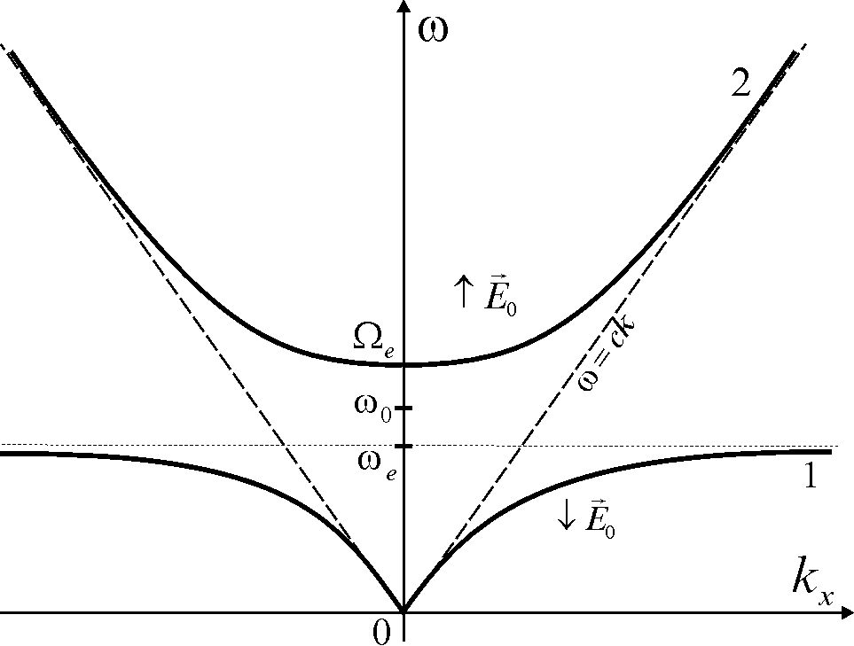

Figure 1

4. Surface Polaritons in Magnetic Field

In the presence of magnetic constant field , directed in the contact plane along axis the dynamic ME interaction induces the non-diagonal component of a dielectric tensor .

The penetration depth of polaritons is inversely proportional to the value of magnetic . The dispersion relation and the depth of penetration are following:

where the expressions for we obtain from by the replacement on . Surface polariton modes in magnetic field are shown in Fig. 2.
In optical region () for the polariton modes are thick solid curves. The modes are not close to each other and the spectrum is strongly nonreciprocal: there are two modes for polaritons running to the left and one mode for polaritons running to the right. Surface polaritons with a given frequency propagate only in one direction with respect to magnetic field. This is the effect of the rectification. The substitution of for in Fig. 2 corresponds to the inversion of the magnetic field . In this case, the dashed curves are the modes of surface polaritons.

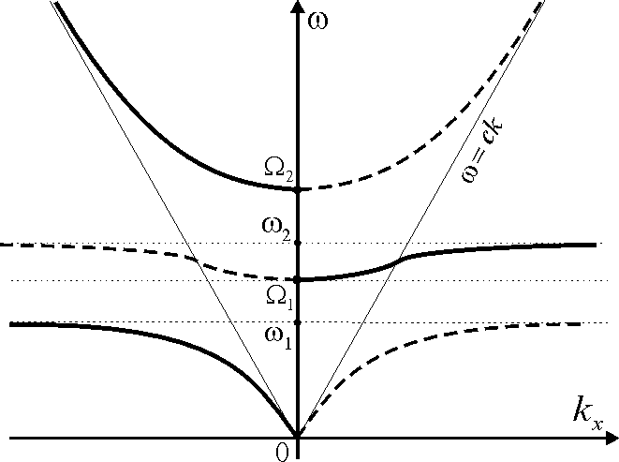

Figure 2

5. Conclusions

Thus, in the presence of a constant electric or magnetic fields the surface polaritons exist in a semi-infinite insulator, which is in contact with an ideal metal or a superconductor. The depth of penetration of polariton field into the insulator is inversely proportional to the value of the field and it is less in optical region than the one for IR region. So, in the optical region of the spectrum . If $H_{0}=\text{10} T$, $δ={\text{10}}^{−2}$cm.
The frequency regions in which surface polaritons exist depend strongly on the direction of the field so a change of the sign of the field signifies the “switching off” or “switching on” of polaritons with a given frequency. In the presence of magnetic field the spectrum is a strong nonreciprocal: surface polaritons propagate only in one direction with respect to magnetic field (the effect of rectification).
The upper modes are radiant modes and may be excited by a direct interaction with electromagnetic wave.

References

[1] V. M. Agranovich and D. L. Mills (Eds.), Surface Polaritons. Amsterdam: North-Holland, 1982.
[2] I. E. Chupis and D. A. Mamaluy, Pis'ma Zh. Eksp. Teor. Fiz., vol. 68, p. 876, 1998, [JETP Letters, vol. 68, p. 922, 1998].
[3] I. E. Chupis and D. A. Mamaluy, J. Phys.: Condensed Matter, vol. 12, p. 1413, 2000.
[4] I. E. Chupis, Ferroelectrics, no. 204, p. 173, 1997.

