Scattering and Absorption Problems Solution
upon the 3-D Chiral and Biisotropic Objects

F. G. Bogdanov, D. D. Karkashadze, and R. S. Zaridze

Tbilisi State University
3 Chavchavadze Ave, 380028 Tbilisi, Georgia
Tel.: +995 32 290821, fax: +995 32 290845, e-mail: rzaridze@resonan.ge

Abstract

An efficient solution to the 3-D scattering and absorption problems of chirality and biisotropy is developed using various types of expansion functions. The necessary conditions to obtain the most optimal solution are outlined. The program complex to compute and visualize scattering, absorption, polarization, energetic, and directive properties of biisotropic and chiral objects is described and applied to solve some applied scattering and antenna problems.

1. Introduction

The problems of microwave behavior of the objects of complicated shape and complex material filling, such as chiral and biisotropic, are to be important both from theoretical and applied viewpoints [1-6]. In this regard, much effort has been devoted in last few years to develop and justify new techniques and codes to solve 2D and 3D problems on chirality and biisotropy. However, most of the results declared for the time being, is restricted to the geometry of objects, the range of material parameters, the type of primary excitation and the accuracy attained and thus no longer satisfy the present-day practical needs.
In this contribution, based on the Method of Auxiliary Sources (MAS) [4-6], an efficient solution to the 3-D scattering and absorption problems of chirality and biisotropy is developed using various types of expansion functions. Farther, the necessary conditions to obtain the most optimal solution are outlined. The program complex to compute and visualize scattering, absorption, polarization, energetic, and directive properties of biisotropic and chiral objects is described. Application of the created computer code to solve the practical problems of interest is illustrated.

2. Brief Description of the Method

The problem discussed here is to find the electromagnetic response of an arbitrary homogeneous biisotropic (including, chiral) object to be excited from outside or within by the given field of primary electromagnetic sources. From the mathematical point of view, this problem can be obviously reduced to solving wave equations
${\hat{ℑ}}^{e,i}\overset{˘}{U}(\vec{r})=0$ (1)
for unknown potential function of scattered field $\overset{˘}{U}(\vec{r})$, with providing the radiation conditions at infinity and satisfying the following boundary conditions on the surface S enclosing the object
$W{\left\{\overset{˘}{U}(\vec{r})+{\overset{˘}{U}}_{0}(\vec{r})\right\}}_{|r=r^{S}}\text{=0,} M({\vec{r}}^{S})∈S$ (2)
Hereinafter, superscripts e and i concern to the exterior and interior domains, respectively, ${\overset{˘}{U}}_{0}(\vec{r})$ is a given function of incident field, and $W$ is an operator of boundary conditions ensuring the fields conjugation on the boundary surface S.
Various techniques to solve the boundary problem (1)-(2) differ actually by the method to construct the solution to the equation (1) and to determine the unknown coefficients arising from satisfying the boundary conditions (2). The MAS, in contrast to most other methods, constructs the solutions to (1) as non-orthogonal expansions in terms of fundamental solutions of (1) with singularities out of the described domain [6]
$\overset{˘}{\tilde{U}}(\vec{r})=\sum_{n=1}^{N^{\text{i,e}}}{a_{n}^{\text{i,e}}{\overset{˘}{Ψ}}_{n}(\vec{r},{\vec{r}}_{n}^{\text{i,e}})},\text{ \{}\vec{r}∈D^{\text{i,e}}$ (3)
The sets of points ${\left\{{\vec{r}}_{n}^{\text{i,e}}\right\}}_{n=1}^{N^{\text{i,e}}}$ to be distributed at the auxiliary surfaces $S^{i,e}$ (Fig. 1) can be interpreted as the centers of auxiliary sources associated with fundamental solutions ${\overset{˘}{U}}_{n}(\vec{r},{\vec{r}}_{n}^{\text{i,e}})$. The amplitudes $a_{n}^{i,e}$ of these sources should be determined from the boundary conditions (2) by any numerical procedure, in particular, by the collocation method.

Fig. 1

3. Application to the Problems of Chirality and Biisotropy

Application of the described scheme to the problems of chirality and biisotropy is of the simplest one if using constitutive relations in Post notations
$\vec{D}=ε\vec{E}+iα\vec{B}\text{, \{}\vec{H}=iβ\vec{E}+μ^{−1}\vec{B}$, (4)
where $ε$ and $μ$ are the medium permittivity and permeability, respectively, $α=ξ−iψ$ and $β=ξ+iψ$ are magnetoelectric admittances, $ξ$ is chirality admittance and $ψ$is nonreciprocity susceptance.
To determine now fundamental solutions of wave equation (1) for constitutive relations (4), it is necessary first choose the type of the potential function $\overset{˘}{U}$. As such a function, any function can be employed which identically define the vectors of electromagnetic field, e.g., electric and magnetic vector potentials ${\vec{A}}^{e,m}$, Debye scalar potentials $Π$, Hertz vectors ${\vec{Z}}^{e,m}$, spinor dyad of Hertz potential $\bar{Z}$, spinor dyad of electromagnetic field $\bar{F}$ or any field vector $\left\{\vec{E}\text{, \{}\vec{H} | | \text{, \{}\vec{D} | | ,\vec{B}\right\}$. It is convenient, however, to choose such a potential function, which leads to the simpler form of wave operator $\hat{ℑ}$ and the relations to the field vectors.
Thus, when choosing $\vec{E}$ or $\vec{H}$ as potential function $\overset{˘}{U}$, wave operator $\hat{ℑ}$ is of the form
$\hat{ℑ}=({\vec{∇}}^{2}+k^{2})\bar{\bar{I}}+\text{ωμ}(α+β)\vec{∇}×\bar{\bar{}}I, k=ω\sqrt{\text{εμ}}$, (5)
and fundamental solutions of wave equation (1) are found to be as follows
$\vec{Ψ}(\vec{r},{\vec{r}}^{'})=\left[\hat{γ^{r}}G^{r}(|\vec{}r−{\vec{r}}^{'}|)−{\hat{γ}}^{ℓ}{\vec{G}}^{ℓ}(|\vec{r}−{\vec{r}}^{'}|)\right]ℜ\vec{τ}(r^{'})$, (6)
where ${\hat{γ}}^{r,l}=\vec{∇}×\bar{\bar{I}}±k_{r,l}^{−1}\vec{∇}\vec{∇}±k_{r,l}\bar{\bar{I}}$ are vector differential operators for right-hand (r) and left-hand ($ℓ$) wavefields, $ℜ=−\frac{1}{\text{ωμ}}\frac{η_{c}^{ℓ}η_{c}^{r}}{η_{c}^{ℓ}+η_{c}^{r}}$ is normalized coefficient, $\bar{\bar{I}}$ is a unit matrix,
$G^{r,ℓ}=\frac{1}{4π|\vec{r}−{\vec{r}}^{'}|}e^{{\text{ik}}_{r,ℓ}|\vec{r}−{\vec{r}}^{'}|}$ (7)
are scalar Green’s functions for outgoing waves with wavenumbers
$k_{r,ℓ}=k$, (8)
and wave impedances
$η_{c}^{r,ℓ}=η/{\left\{1+η^{2}(α+β{)^{2}}/4]^{1/2}±η(α−β)/2\right\}}$, (9)
$\vec{τ}({\vec{r}}^{'})$ is a unit vector tangential to the auxiliary surface at the point $M^{'}({\vec{r}}^{'})$.
If introducing as potential function the spinor dyad of electromagnetic field $\overset{˘}{U}≡\bar{F}$, wave operator $\hat{ℑ}$ is of the form
$\hat{ℑ}=\vec{∇}×\bar{\bar{I}}−\bar{k}\bar{\bar{I}}$ (10)
and the fundamental solutions of (1) are obtained to be as follows
$\bar{Ψ}\left(\vec{r}−{\vec{r}}^{'}\right)=\bar{\hat{γ}}\bar{G}\left(\vec{r}−{\vec{r}}^{'}\right)ℜ\bar{τ}$ (11)
where $\bar{k}=\left(\begin{matrix}k_{{}^{r}} & 0 \\ 0 & −k_{{}^{ℓ}}\end{matrix}\right)$, $\bar{\hat{γ}}=\left(\begin{matrix}\hat{γ^{r}} & 0 \\ 0 & −{\hat{γ}}^{ℓ}\end{matrix}\right)$ and $\bar{G}=\left(\begin{matrix}G^{{}_{{}^{r}}} & 0 \\ 0 & G^{{}_{{}^{ℓ}}}\end{matrix}\right)$ are the matrices of wave-numbers, vector differential operators and Green's functions for right- and left-hand wavefields, respectively. The field vectors $\vec{E}$ and $\vec{H}$ can be found over the potential function via relations
$\vec{E}=\bar{χ}\bar{F},\text{ \{}\vec{H}=\bar{ζ}\bar{F}$, (12)
with rows of parameters
$\bar{χ}=({iη}_{c}^{r},\text{ -}{iη}_{c}^{ℓ}),\text{ \{}\bar{ζ}=(1,1)$ (13)
The knowledge of fundamental solutions of wave equation (1) for biisotropic (including, chiral) medium formally completes the construction of solution (3) to the stated boundary problem (1)-(2).

4. Numerical Results

To numerically calculate electromagnetic characteristics of chiral or biisotropic objects by the present method, it is necessary to determine the coefficients $a_{n}^{i,e}$ of expansions (3) from the boundary conditions (2). To provide the quick convergence and minimal discrepancy of the solution to be sought, the proper choice of the auxiliary parameters, such as the shape and dimensions of auxiliary surface, distribution of the points on the boundary and auxiliary surfaces, etc., is required. It is especially important to properly account for the character and situation of the singularities of continuously extended scattered field across the boundary of the domain to be described.
All the aspects above have been considered to produce the program complex for calculating and visualizing scattering, absorption, polarization, energetic, and directive characteristics of 3-D chiral and biisotropic objects. In the code performed, both isolated and integrated auxiliary sources have been utilized to obtain the optimized and effective solutions. We illustrate here some possibilities of the created code to calculate and visualize radiation, propagation and scattering problems of interest.
Fig. 2 and 3 compare the radiation processes produced by a linear current source placed in a back focus of biisotropic ellipsoid of revolution along (Fig. 2) and perpendicular (Fig. 3) to the axis of revolution. The geometry of ellipsoid is determined by its semi-axises: a = 0.5, b = 0.4, and medium parameters are: $ε_{r}=2\text{.}\text{00006}$, $μ_{r}=2\text{.}\text{02502}$, ${\text{αη}}_{0}=0\text{.}\text{1885}+i0\text{.}\text{754}$, ${\text{βη}}_{0}=0\text{.}\text{1885}−i0\text{.}\text{754}$ ($η_{0}=\text{120}π$). We are interested in distribution of energy density of right-hand (a) and left-hand (b) wavefields outside the ellipsoid for wavenumber k = 32. The parameters of biisotropic medium are chosen so, that mainly left-hand polarization is focused along the axis of ellipsoid. The comparison of Fig. 2 and 3 also shows, that the transverse current source manifests more focusing properties.
Fig. 4 shows the 3-D radiation pattern of ellipsoid of revolution of Fig. 2 and 3 with longitudinal (a) and transverse (b) excitation. From comparison of Fig. 4-a) and 4-b), it is obvious, that transverse current excitation leads to better directive pattern with weaker lobes. It is also clear, that this pattern is not omnidirectional, and thus one of polarization (left-hand) is dominant. Fig. 5 calculated for situation of Fig. 4-a), but with k = 400, shows the increase of directivity and decrease of radiation lobes with growing wavenumber (frequency).
It should be noted, that Fig. 2-5 have been calculated with rather high accuracy (about 0.5%) and only thus allow studying in detail electromagnetic properties of scattering biisotropic objects. Thus, the proper use of the method described allows one to obtain numerical results with predesigned accuracy and to study the practical problems of interest.

References
- A. Lakhtakia, Beltrami Fields in Chiral Media. World Sci. Publ. Co., pp. 1-536, 1994.
- I. V. Lindell, A. H. Sihvola, S. A. Tretyakov, and A. J. Viitanen, Electromagnetic Waves in Chiral and Bi-Isotropic Media. Artech House: Boston, London , pp. 1-332, 1994.
- J. C. Monzon, “Scattering by a biisotropic body,” IEEE Trans. Antennas Prop. 43, Vol. 11, pp. 1273, 1995.
- F. G. Bogdanov and D. D. Karkashadze, “Conventional method of auxiliary sources in the problems of electromagnetic scattering by the bodies of complex materials,” Electromagnetic and Light Scattering - Theory and Applications, Bremen, Germany , pp. 133-140, 1998.
- F. G. Bogdanov, D. D. Karkashadze., and R. S. Zaridze, “Propagation and scattering by biisotropic objects of complicated shape,” in Proc. Bianisotropics'98, 7th International Conf. on Complex Media, Braunschweig, Germany, pp. 133-136, 1998.
- F. G. Bogdanov, D. D. Karkashadze, and R. S. Zaridze, “The method of auxiliary sources in electromagnetic scattering problems,” in Generalized Multipole Techniques for Electromagnetic and Light Scattering, Th. Wriedt (Ed.). Elsevier Science B.V., pp. 143-172, 1999.

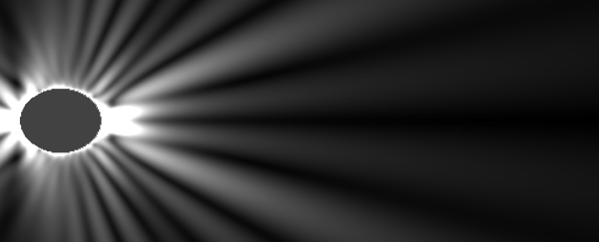 | 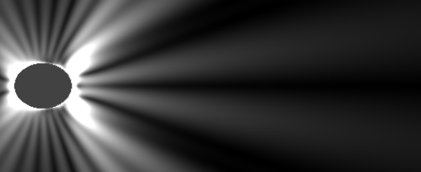
a) | b)
Fig. 2
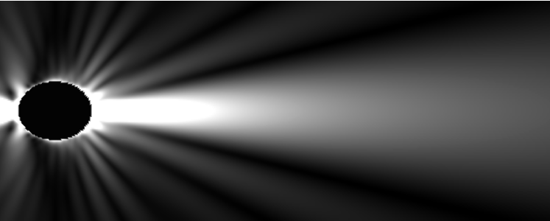 | 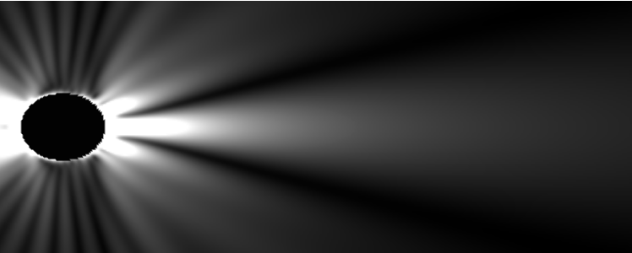
a) | b)
Fig. 3
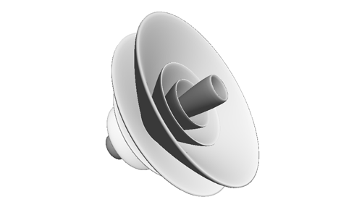 | 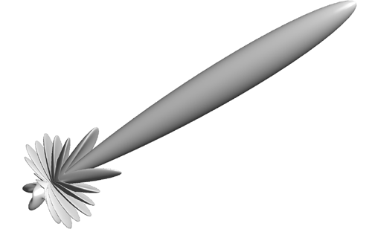
a) | b)
Fig. 4

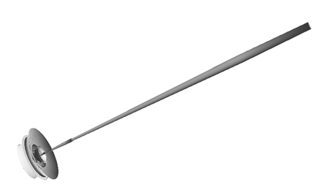

Fig. 5

